 | International Journal of Advanced Nursing Studies, 8 (x) (2019) xxx-xxx  International Journal of Advanced Nursing Studies  Website: www.sciencepubco.com/index.php/IJANS  Research paper, Short communication, Review, Technical paper | 

Title of the article
First Author¹*, Second Author², Third Author³
¹Affiliation of the first author
²Affiliation of the second author
³Affiliation of the third author
*Corresponding author E-mail:

Abstract

The manuscript should contain an abstract. The abstract should be self-contained and citation-free and should not exceed 300 words. The abstract should state the purpose, approach, results and conclusions of the paper. The author should assume that the reader has some knowledge of the subject but has not read the paper. Thus, the abstract should be intelligible and complete in it-self (no numerical references); it should not cite figures, tables, or sections of the paper. The abstract should be written using third person instead of first person.

Keywords: Use about five key words or phrases in alphabetical order, Separated by Semicolon.

- Introduction
This document can be used as a template for Microsoft Word versions 6.0 or later. Do not submit papers written with other editors than MS Word, it will not be accepted for review. Save the files to be compatible with many versions of MSWord (avoid other document extension than *.doc, *.docx or *.rtf). Do not submit papers without performing a carefully spellcheck and English language grammar check. The style from these instructions will adjust your fonts and line spacing. Please do not change the font sizes or line spacing to squeeze more text into a limited number of pages.
- Page layout
An easy way to comply with the paper formatting requirements is to use this document as a template and simply type your text into it.
Your paper must use a page size corresponding to A4 which is 21cm wide and 29.7cm long. The margins must be set as follows:
Top = 1.5cm
Bottom = 1.5cm
Left =2cm
Right=1.5cm
Your paper must be in two column format with a space of 0.5cm between columns.

2.1. The paper should have the following structure
1. Title of the paper
2. Authors and affiliations
3. Abstract
4. Keywords
5. Introduction
6. Main body
7. Conclusions
8. References
- Page style
All paragraphs must be justified alignment. With justified alignment, both sides of the paragraph are straight.

3.1. Text font of entire document
The entire document should be in Times New Roman. The font sizes to be used are specified in Table 1.

3.2. Title and author details
All title and author details must be in single-column format and must be centered.
Only the first word in a title must be capital and other word should be in small case. Author details must not show any professional title (e.g. Managing Director), any academic title (e.g. Dr.) or any membership of any professional organization (e.g. Senior Member IEEE).
To avoid confusion, the family name must be written as the last part of each author name (e.g. John A.K. Smith).
Each affiliation must include, at the very least, the name of the company and the name of the country where the author is based (e.g. Causal Productions Pty Ltd, Australia). Email address is compulsory for the corresponding author.

3.3. Section headings
No more than 3 levels of headings should be used. Other headings must be in 9pt font. Only the first word in a heading must be capitalized and other word should be in small case.
Level-1 Heading: A level-1 heading must be in left-justified and numbered with an Arabic numeral. The two level-1 headings which must not be numbered are “Acknowledgment” and “References”.
Level-2 Heading: A level-2 heading must be left-justified and numbered with an Arabic numeral followed by a period.
Level-3 Heading: A level-3 heading must be numbered with an Arabic numeral.
The section should be formatted as left, bold, Times New Roman, and 12pt font size. For subsection (left, bold, Times New Roman, and 10pt), the initial letter of first word should be capitalized and also similarly for other sub-subsections (left, bold, Times New Roman, and 9pt).

Table 1: Font Specifications for A4 Papers

Font Size | Appearance (in Time New Roman)
Font Size | Regular | Bold
8 | table caption, centered  figure caption, centered  reference item
9 | Author’s affiliation, centered  Paragraph  abstract body | level-3 heading, left-justified
10 |  | author name, centered  level-2 heading, left-justified
12 |  | level-1 heading, left-justified  reference heading  acknowledgement heading
18 |  | Paper title, centered

3.4. Figures and tables
Graphs and other numbered figures should appear throughout the text as close to their mention as possible. Figures shouldn’t infringe upon the page borders.
Figures and tables must be centered in the column. Large figures and table can be in one column in order to see them more clearly and avoid placing them in the middle of columns. Any table or figure that takes up more than 1 column width must be positioned either at the top or at the bottom of the page
Photos must be crystal clear with such resolution to allow fine details visibility. The elements from any photo must be explained using numbers, letters, etc. The text within a figure or photo must have the same style, shape and height as the caption has.
Any table, figure or picture must have a caption (Fig.1, Table1, etc.) followed by a proper description. All similar graphics must be generated using the same software product (Excel, Origin, Mathematica, etc.). Importing graphics into the article as images (JPG, BMP, PNG, etc.) should be avoided. All similar electronic schematics, charts, program flow, simulated characteristics, etc. from the article should be generated using the same software product. Importing images from other articles or books it’s totally forbidden unless they are cited.
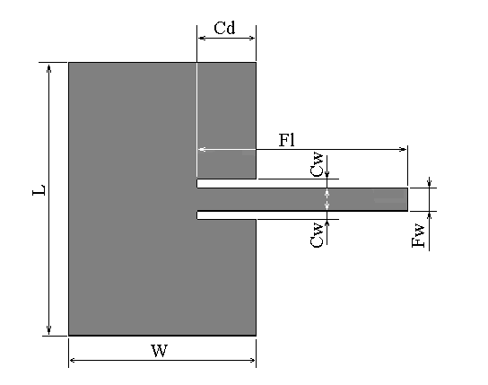
Fig. 1: The text within the figure is Times New Roman, with equivalent height of 10 point, as the caption is. All letters used in the figure are explained in the caption: L = patch length, W = patch width, Cd = cut depth, Cw = cut width, Fl = feed length, Fw = feed width.
3.4.1. Figure captions
Figures must be numbered using Arabic numerals. Figure captions must be in 8 pt Regular font. Captions of a single line (e.g. Figure 2) must be centered whereas multi-line captions must be justified (e.g. Figure 1). Captions with figure numbers must be placed after their associated figures, as shown in Figure 1.
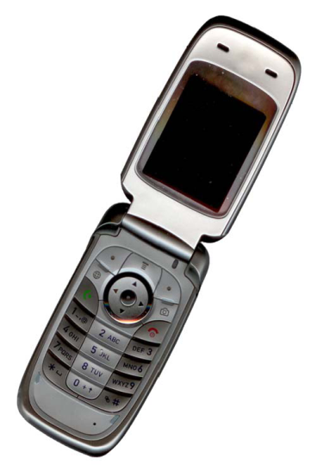
Fig. 2: Example of an image with acceptable resolution
3.4.2. Table captions
Tables must be numbered using Arabic numerals. Table captions must be centred and in 8pt Regular font. Captions with table numbers must be placed before their associated tables, as shown in Table 1.

3.5. Links and bookmarks
All hypertext links and section bookmarks will be removed from papers during the processing of papers for publication. If you need to refer to an Internet email address or URL in your paper, you must type out the address or URL fully in Regular font.

3.6. Equations
Equations should be numbered consecutively throughout the paper. The equation number is enclosed in parentheses and placed flush right, as in (1). Your equation should be typed using the Times New Roman font (please no other font). To create multileveled equations, it may be necessary to treat the equation as a graphic and insert it into the text after your paper is styled.

(1)

Definition 2.1: This is a text of a definition.

(2)

Use the same symbol into a definition over the entire article. Use correct symbols for physical or technical terms. (Example: ε₀ and not ε0 for permittivity). Do not repeat definitions over the article. Refer to already defined symbols, equations, theorems by using the cross reference number (Example: As pointed in (1) the…).
- References
The editor and publisher recommend that citation of online published papers and other material should be done via a DOI (digital object identifier), which all reputable online published material should have – see www.doi.org for more information. If an author cites anything which does not have a DOI they run the risk of the cited material not being traceable.
References within the text should cite the authors' names followed by the date of publication, in chronological date order, e.g. (Lewis 1975, Barnett 1992, Chalmers 1994). Where there are more than two authors, the first author's name followed by et al. will suffice, e.g. (Barder et al. 1994), but all authors should be cited in the reference list. 'et al.' should be presented in italics followed by a full stop only. Page numbers should be given in the text for all quotations, e.g. (Chalmers 1994, p. 7). All references should be cited from primary sources.
Where more than one reference is being cited in the same pair of brackets the reference should be separated by a comma; authors and dates should not be separated by a comma, thus (Smith 1970, Jones 1980). Where there are two authors being cited in brackets then they should be joined by an '&', thus (Smith & Jones 1975).
When a paper is cited, the reference list should include authors' surnames and initials, date of publication, title of paper, name of journal in full (not abbreviated), volume number, and first and last page numbers. Example: Watson R, Hoogbruin AL, Rumeu C, Beunza M, Barbarin B, MacDonald J & McReady T (2003) Differences and similarities in the perception of caring between Spanish and United Kingdom nurses. Journal of Clinical Nursing 12, 85-92.
When a book is cited, the title should be stated, followed by the publisher and town, county/state (and country if necessary) of publication. Example: Smith GD & Watson R (2004) Gastroenterology for Nurses. Blackwell Science, Oxford.
Where the reference relates to a chapter in an edited book, details of author and editors should be given as well as publisher, place of publication, and first and last page numbers. Example: Chalmers KI (1994) Searching for health needs: the work of health visiting. In Research and its Application (Smith JP ed.), Blackwell Science, Oxford, pp. 143-165.
The edition (where appropriate) of all books should be identified, e.g. 2nd edn. References stated as being 'in press' must have been accepted for publication and a letter of proof from the relevant journal must accompany the final accepted manuscript. Please provide access details for online references where possible: Example: Lynaugh JE (1997) The International Council of Nurses is Almost 100 years old. University of Pennsylvania, PA. Available at: http://www.nursing.upenn.edu/history/Chronicle/F97/icn.htm (accessed 12 December 2002). The reference list should be prepared on a separate sheet and be in alphabetical order and chronological order by first authors' surnames.
Website references should include the most recent date of access. Example: Centers for Medicare & Medicaid Services, U.S. Department of Health and Human Services. CMS proposals to implement certain disclosure provisions of the Affordable Care Act. Available at:
http://www.cms.gov/apps/media/press/factsheet.asp?Counter=4221. Accessed January 30, 2012.
Personal communications and unpublished data should be cited in the body of the paper in parentheses, not listed in the references section. Manuscripts that have been accepted for publication may be listed as “in press” with DOI if available; manuscripts that have been submitted or are under revision but have not been accepted may not be cited as references.
- A step before the final submission
Detailed submission guidelines can be found on the journal web pages. All authors are responsible for understanding these guidelines before submitting their manuscript.
- Conclusion
In this section you should present the conclusion of the paper. Conclusions must focus on the novelty and exceptional results you acquired. Allow a sufficient space in the article for conclusions. Do not repeat the contents of Introduction or the Abstract. Focus on the essential things of your article.
Acknowledgement
This is a text of acknowledgements. Do not forget people who have assisted you on your work. Do not exaggerate with thanks. If your work has been paid by a Grant, mention the Grant name and number here.
References
- Cho JH, Chang SA, Kwon HS, Choi YH, KoSH, Moon SD, Yoo SJ, Song KH, Son HS, Kim HS, Lee WC, Cha BY, Son HY & Yoon KH (2006), Long-term effect of the internet-based glucose monitoring system on HbA1c Reduction and glucose stability: a 30-month follow-up study for diabetes management with a ubiquitous medical care system. Diabetes Care 29, 2625–2631.
- Fauci AS, Braunwald E, Kasper DL & Hauser SL (2008), Principles of Harrison’s Internal Medicine, Vol. 9, 17thedn. McGraw-Hill, New York, NY, pp.2275–2304.
- Kim HS & Jeong HS (2007), A nurse short message service by cellular phone in type-2 diabetic patients for six months. Journal of Clinical Nursing 16, 1082–1087.
- Lee JR, Kim SA, Yoo JW & Kang YK (2007), The present status of diabetes education and the role recognition as a diabetes educator of nurses in korea. Diabetes Research and Clinical Practice 77, 199–204.
- McMahon GT, Gomes HE, Hohne SH, Hu TM, Levine BA & Conlin PR (2005), Web-based care management in patients with poorly controlled diabetes. Diabetes Care 28, 1624–1629.
- Thakurdesai PA, Kole PL & Pareek RP (2004), Evaluation of the quality and contents of diabetes mellitus patient education on Internet. Patient Education and Counseling 53, 309–313.

