Fig. 1: Schematic variation of the temperature, displacement and the pressure as function of holding time SPS.

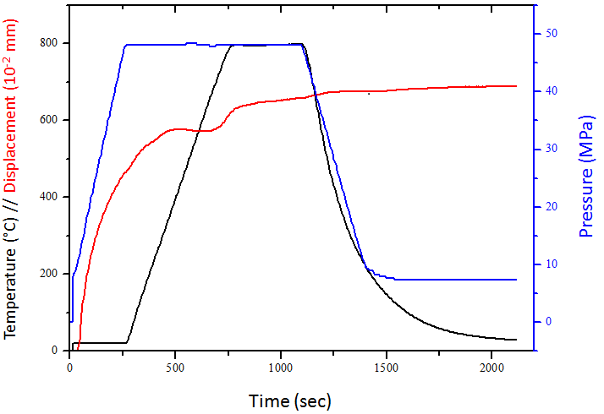

Fig. 2: ¹H and ³¹P MAS NMR spectra of hydroxyapatite powders dried at 80 °C

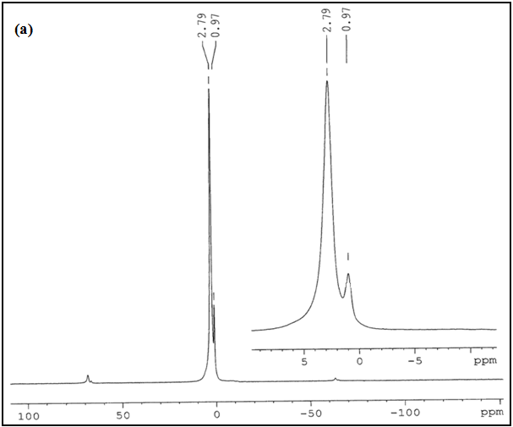
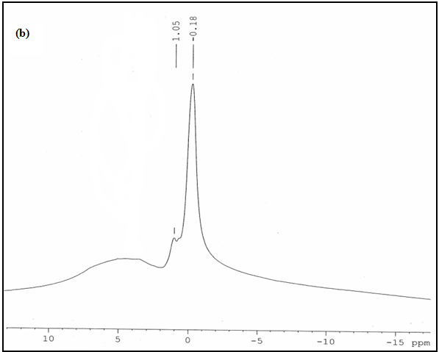

Fig. 3: XRD patterns of samples prepared HA in EG (a) and discs sintered at various temperatures: (b) 800°C; (c) 850°C; (d) 900°C; (e) 950°C.

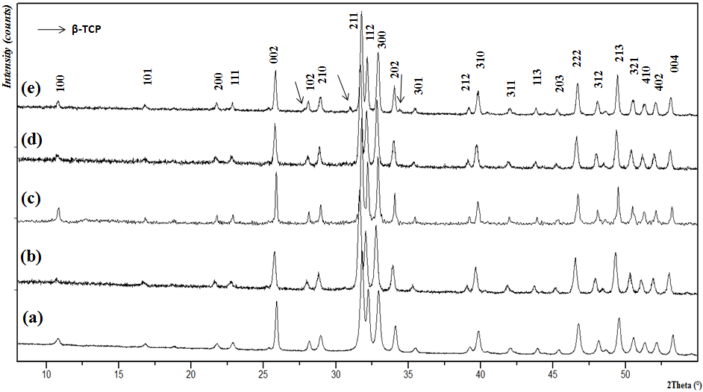

Fig. 4: SEM images of sample HA SPSed for 5 min under 50 MPa and their sizes distributions: (a) 800°C; (b) 850°C;(c) 900°C; (d) 950°C, The fit of the distribution by a Lorentzian is also reported (black line)

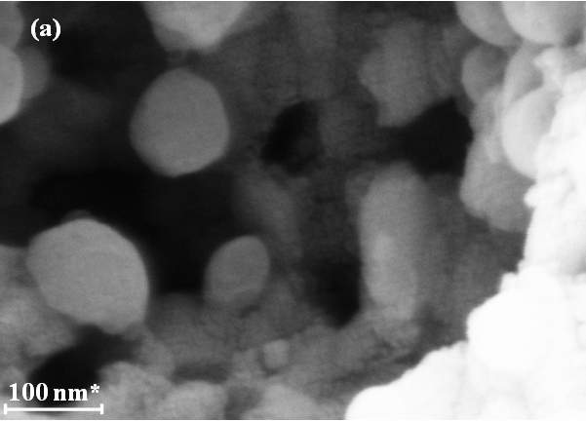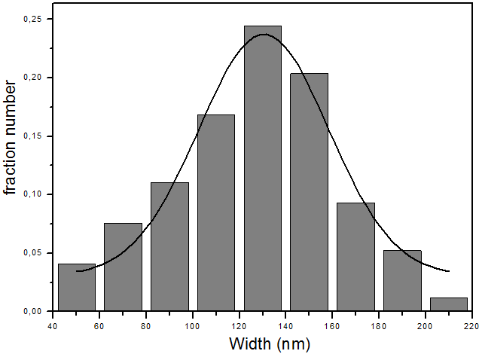
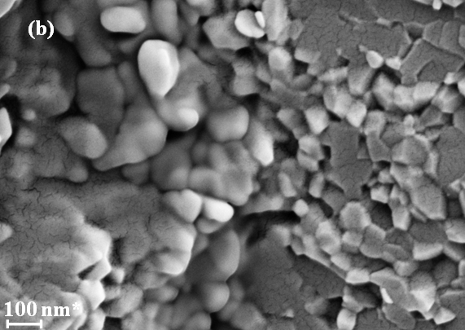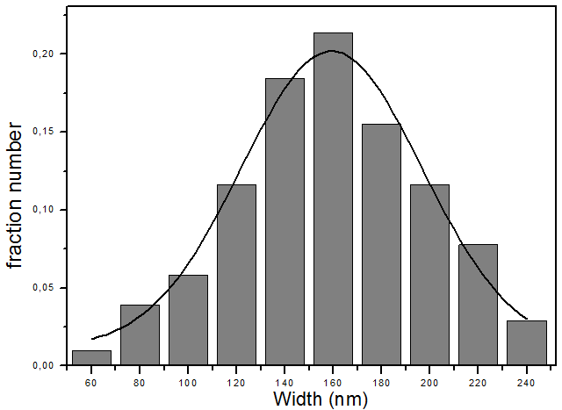
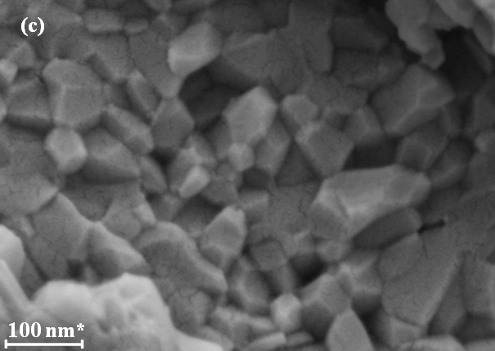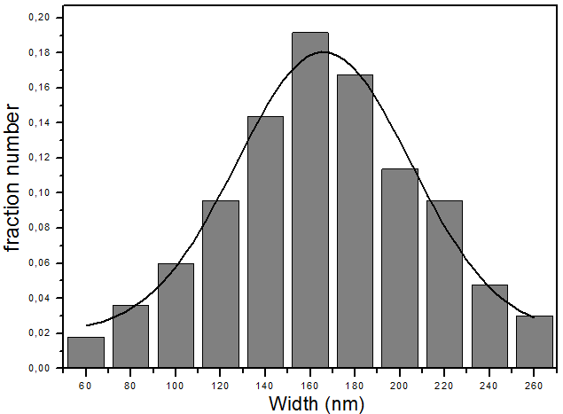
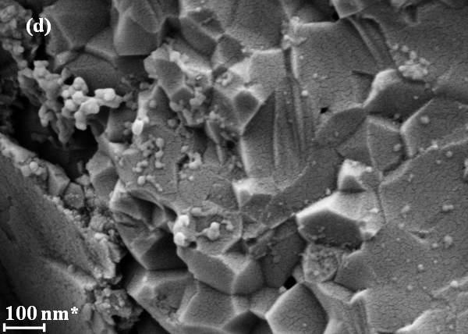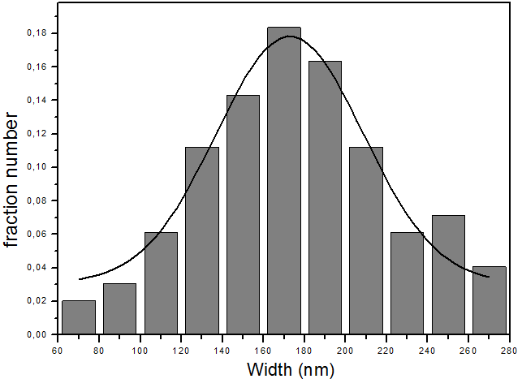

Fig. 5: The Vickers hardness of various sintered samples vs. sintering temperature.

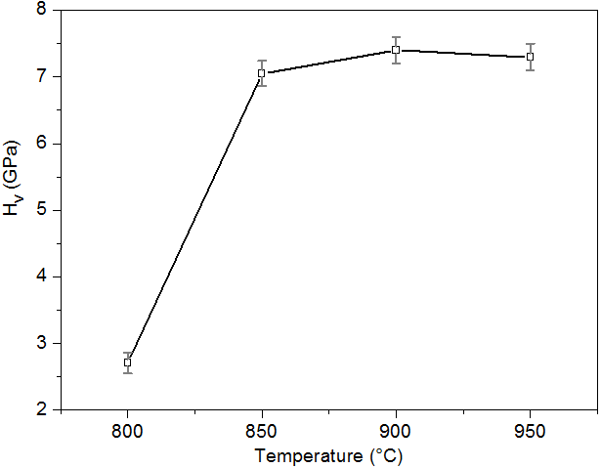

Fig. 6: Effect of sintering temperature on the fracture toughness of HA sintered by SPS

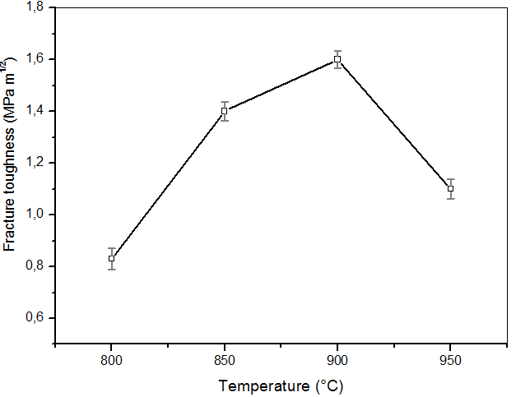

Fig. 7: Young's modulus (E) and Berkovich Hardness (H_{B}) measured as a function of the sintering temperature.

