**Supporting Information**

**Synthesis Photophysical Studies Of Some Furfuryl Nitrones: Highly Selective Chemosensors for Zn2+ and DFTStudies**

**Ezhumalai Dhineshkumar, Mathivanan Iyappan, Rajendran Ganapathi and Chinnadurai Anbuselvan*#**

*Department of Chemistry, Annamalai University, Annamalainagar − 608 002, India.*

*Corresponding author: Address

**C. Anbuselvan**

Assistant professor,

Department of Chemistry

Annamalai University

Annamalainagar 608 002

E-mail: [*cas_amu@yahoo.co.in*](mailto:cas_amu@yahoo.co.in)

Mobile: +91 99940 75907

#Presently at PG and Research Department of Chemistry, Government Arts College Chidambaram-608102, India.

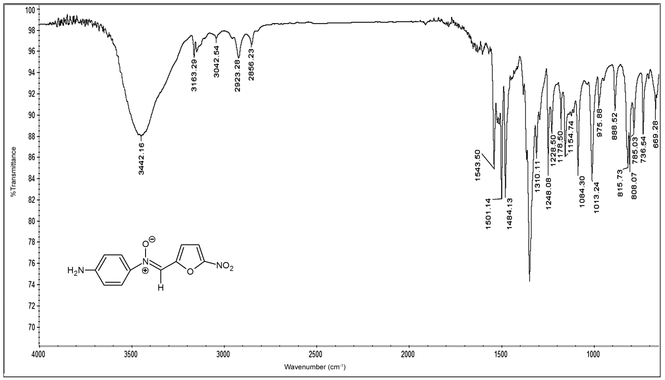**Fig.S1. FT-IR spectrum of compound 1** 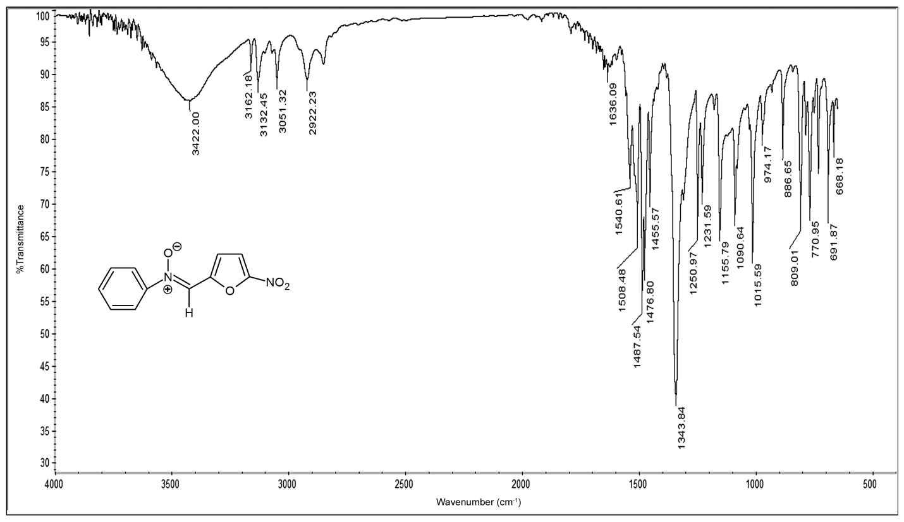

**Fig.S2. FT-IR spectrum of compound 2**

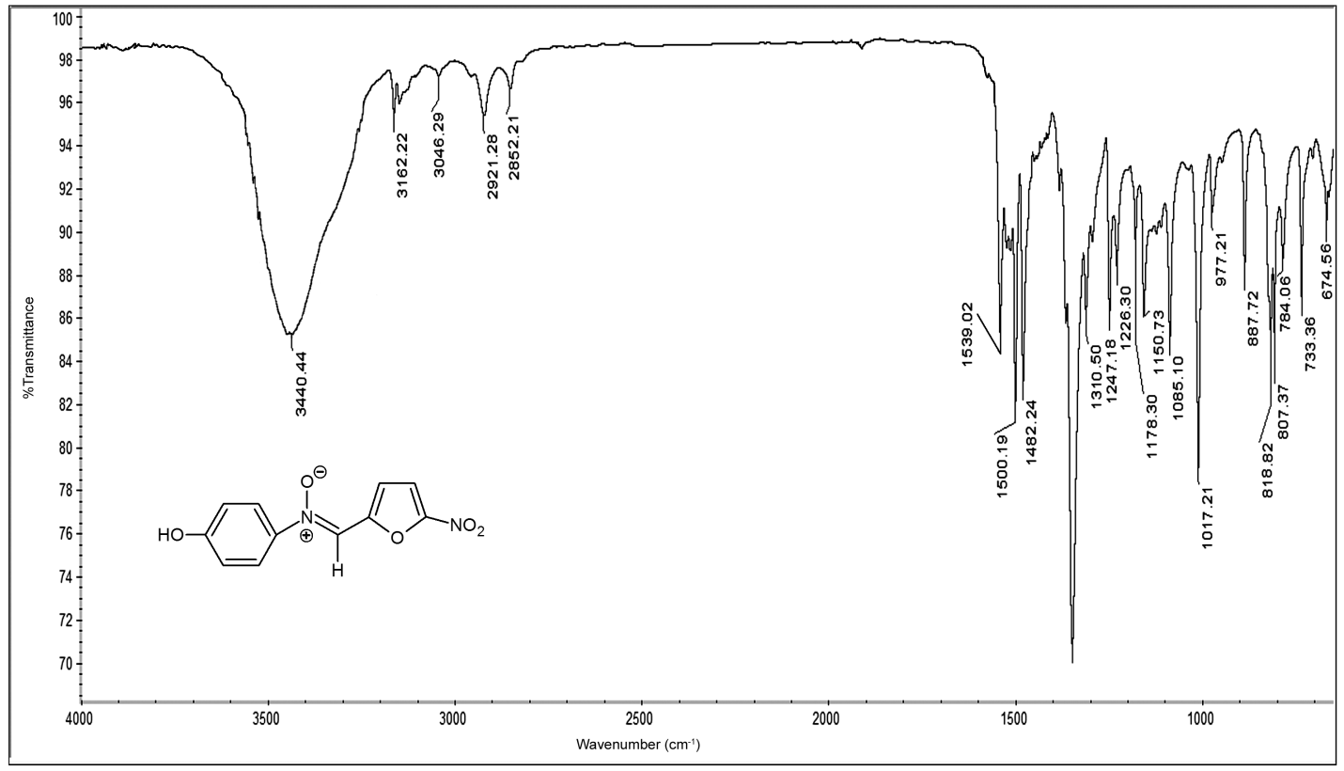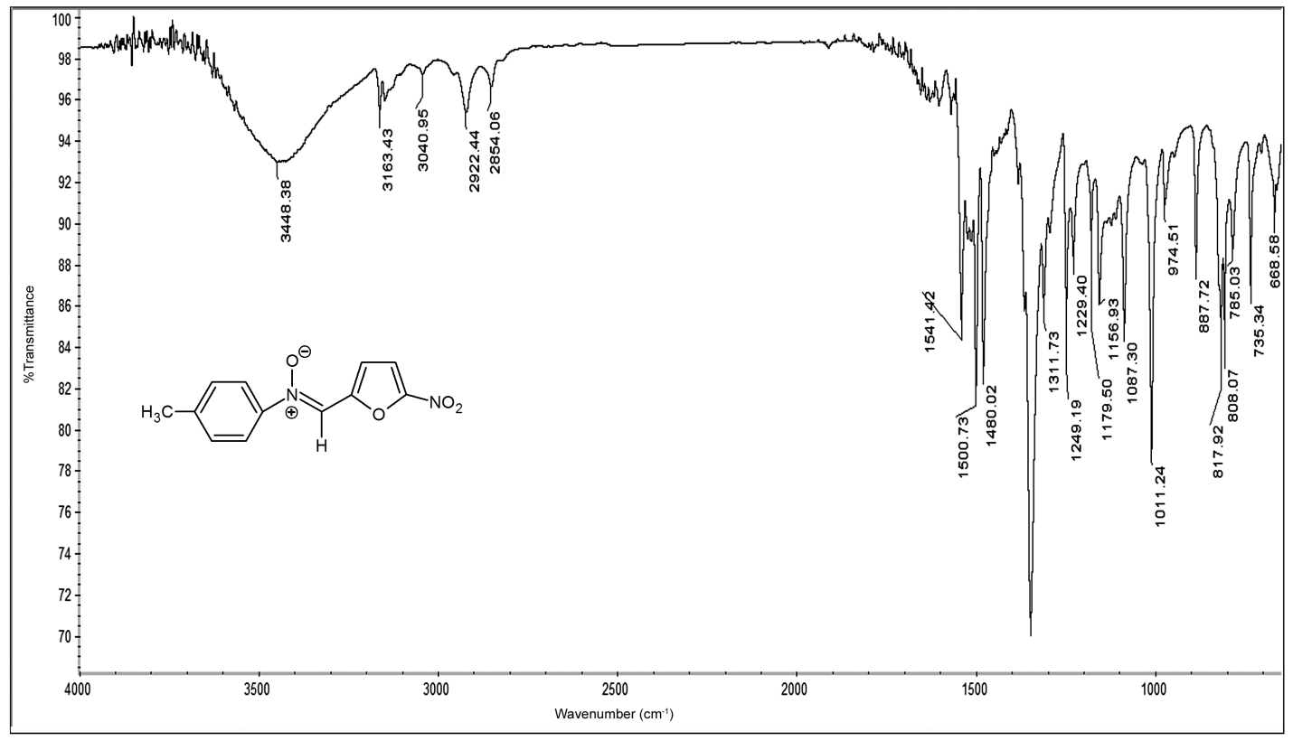**Fig.S3. FT-IR spectrum of compound 3**

**Fig.S4. FT-IR spectrum of compound 4**

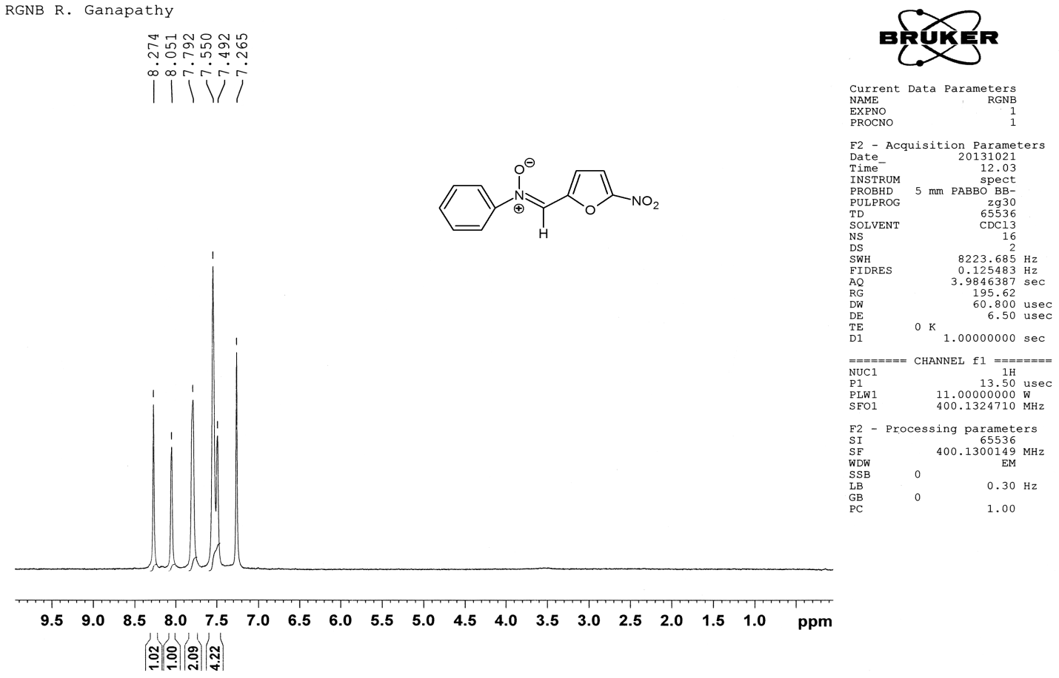Fig.S5. 1H NMR spectrum of compound 1

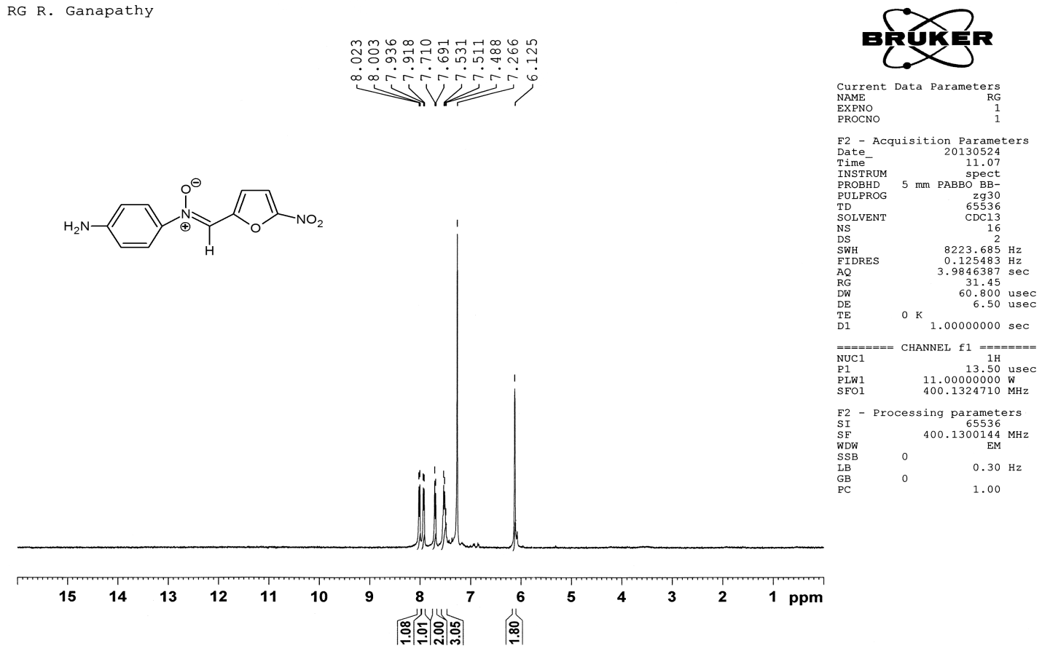

**Fig.S6. 1H NMR spectrum of compound 2**

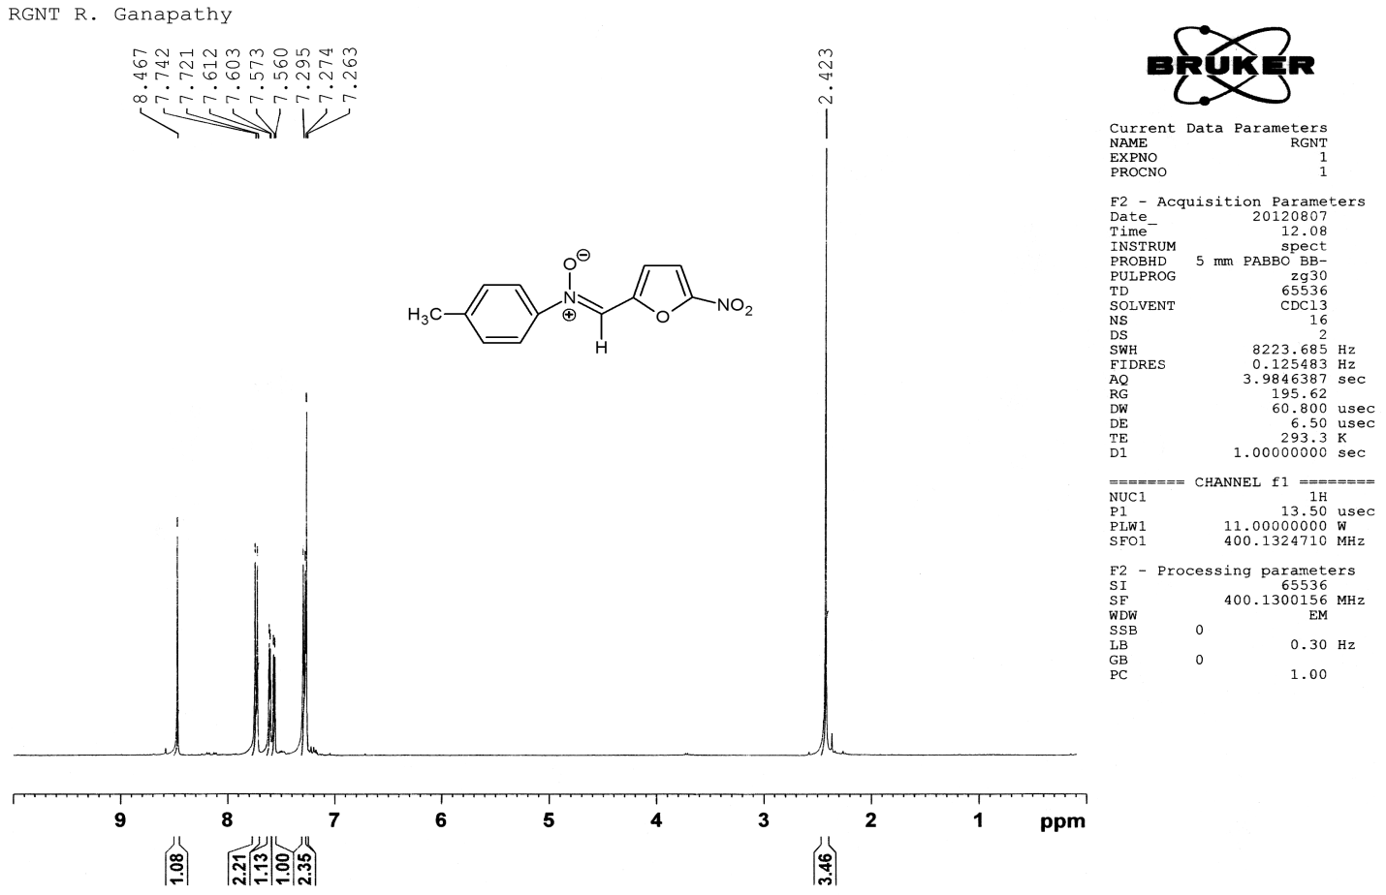**Fig.S7. 1H NMR spectrum of compound 3**

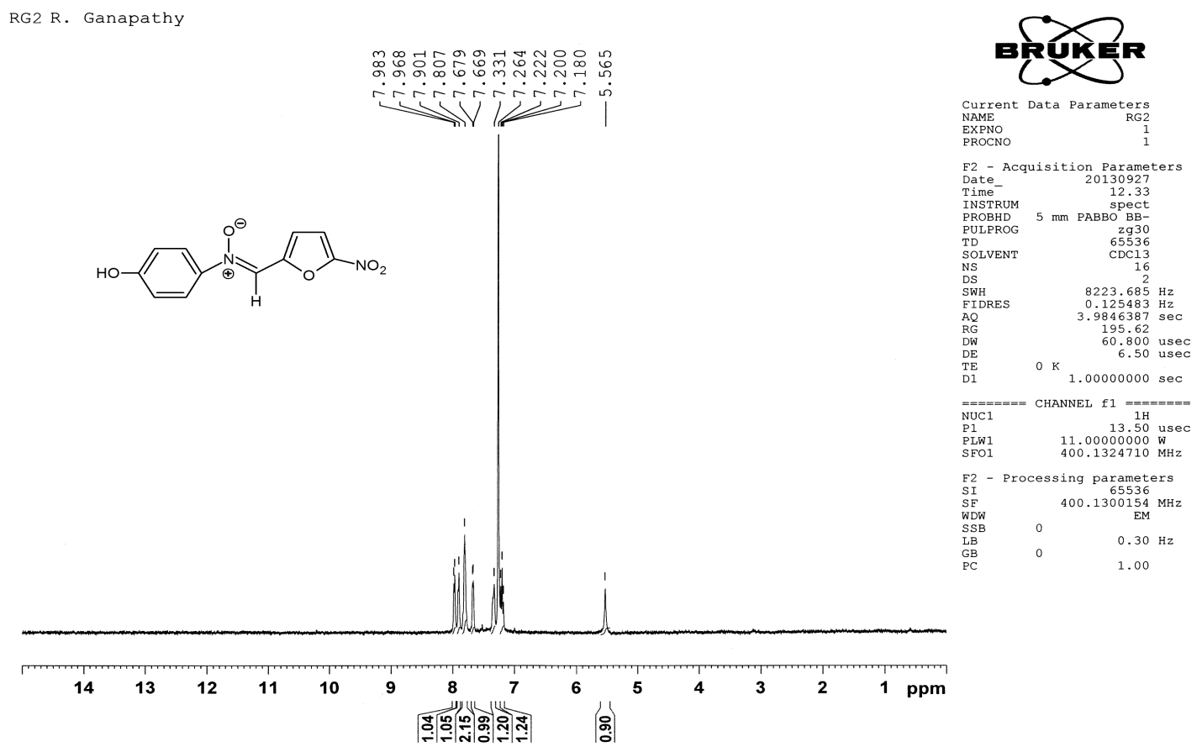 **Fig.S8. 1H NMR spectrum of compound 4**

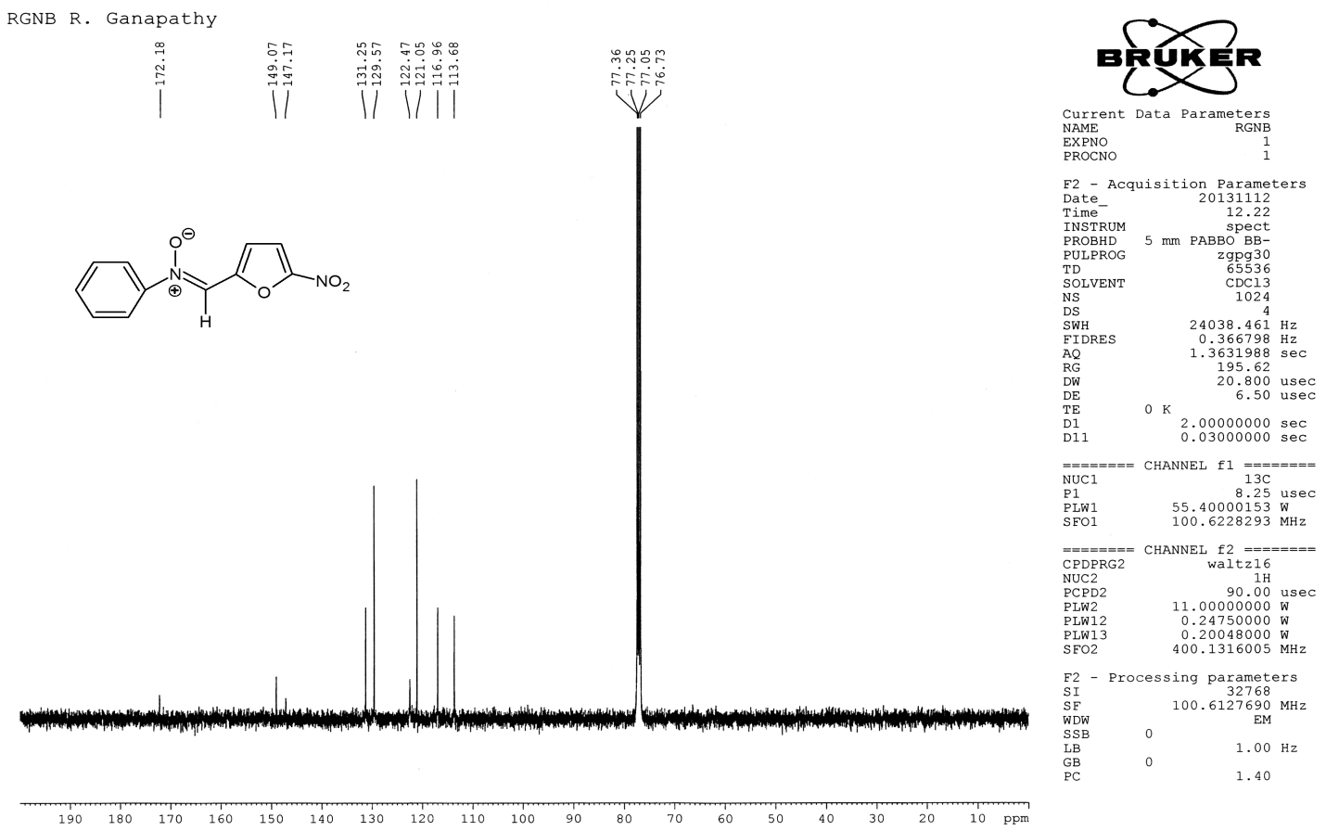

**Fig.S9. 13C NMR spectrum of compound 1**

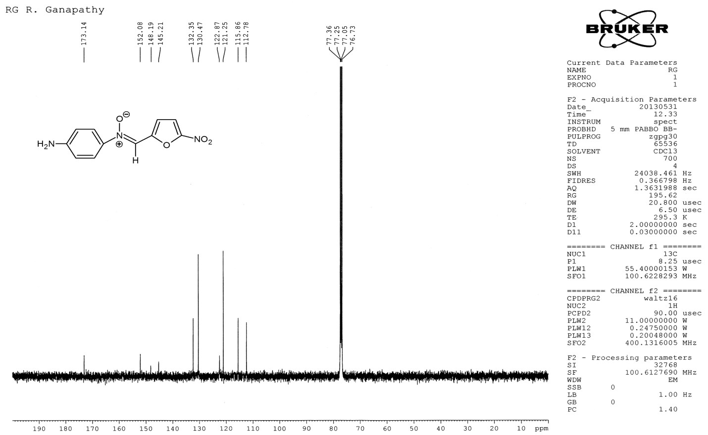 **Fig.S10. 13C NMR spectrum of compound 2**

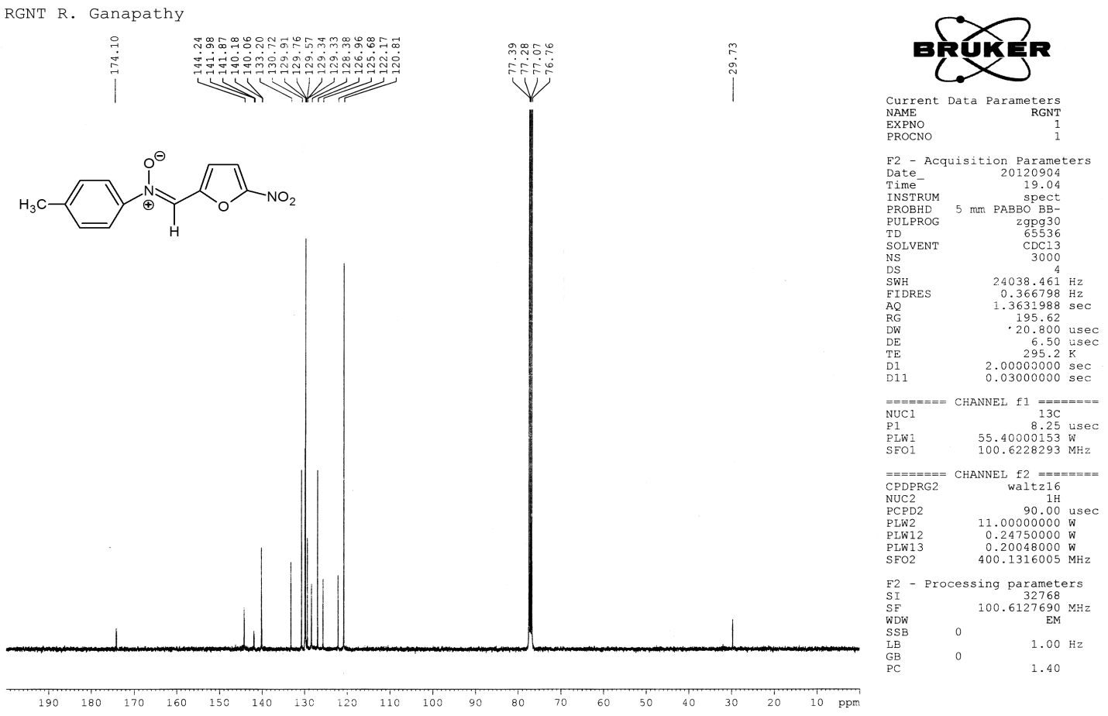 **Fig.S11. 13C NMR spectrum of compound 3**

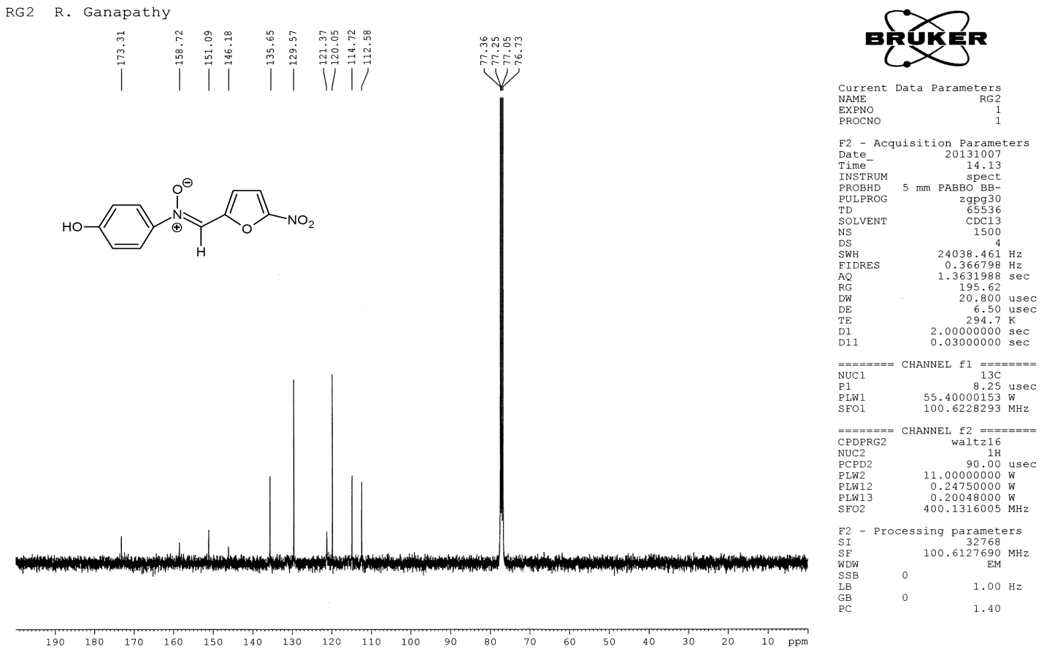 **Fig.S12. 13C NMR spectrum of compound 4**

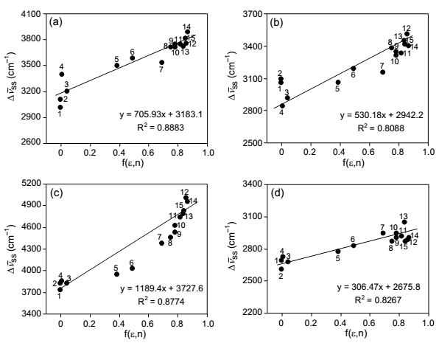

**1**

**2**

**3**

**4**

**Fig. S14.** Plot of Stokes shifts (cm-1) *Vs* f(ε,n) for compounds **1-4.**

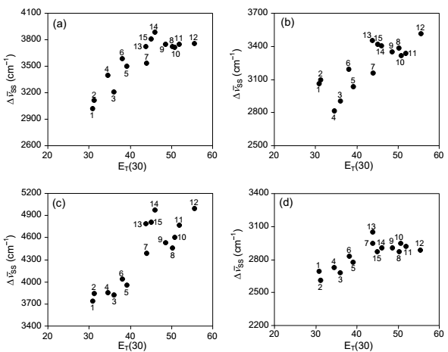

**Fig. S13.** Plot of Stokes shifts (cm-1) *Vs* ET(30) for compounds **1-4.**

**1**

**2**

**4**

**3**

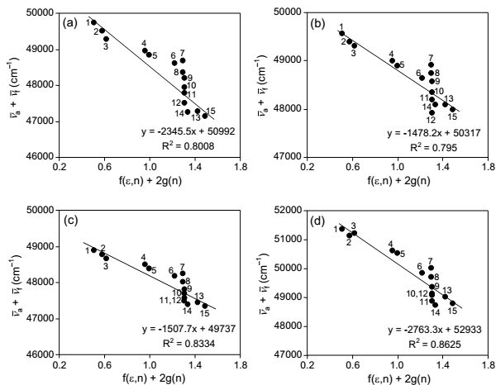

**Fig. S15.** Plot of Kawski correlation  (cm-1) *Vs* f(ε,n) + 2g(n) for compounds **1-4.**

**1**

**2**

**3**

**4**

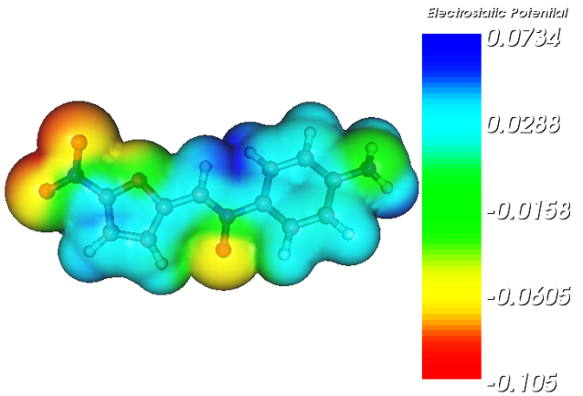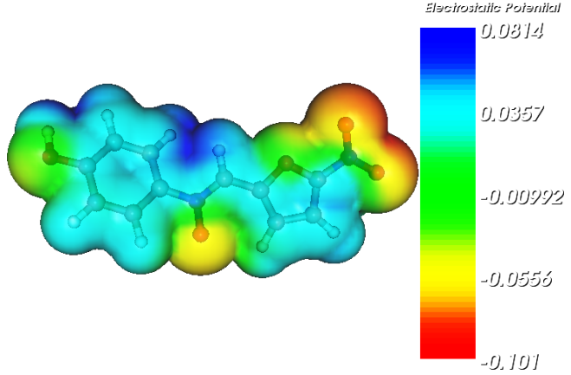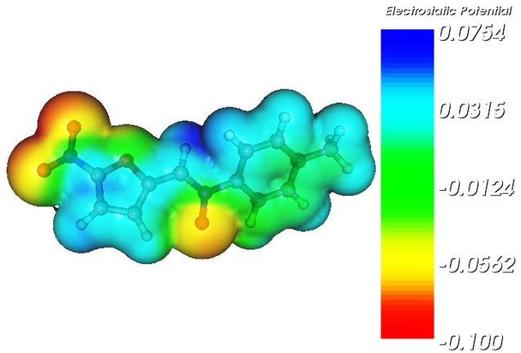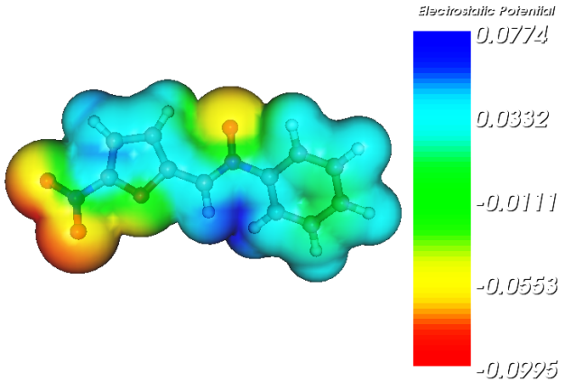

**Fig. S16**. MEP diagram of compounds **1-4**

**1**

**2**

**3**

**4**

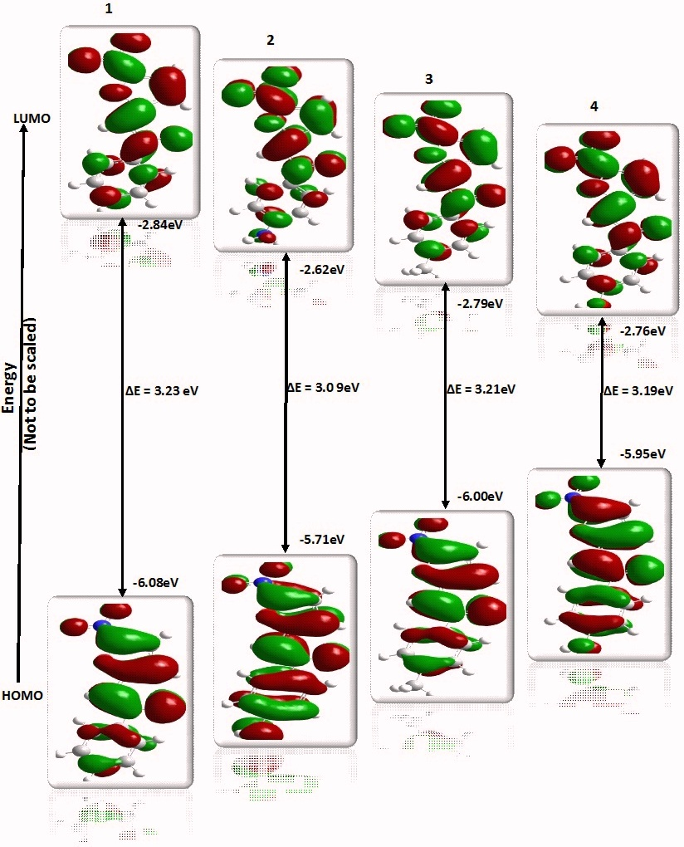

**Fig. S17.** HOMO and LUMO diagram of compounds **1-4**