|  |  |  |
| --- | --- | --- |
|  | ***International Journal of Advanced Geosciences****, 12 (2) (2024) 127-138*  **International Journal of Advanced Geosciences**  *Website: www.sciencepubco.com/index.php/IJAG*  ***Research paper*** |  |

|  |
| --- |
| Integration of slingram (geonics em34-3) and Schlumberger configuration for groundwater exploration and  development of Ayegunle-Oka,  southwestern Nigeria |
|  |
| **Cyril C. Okpoli 1 *, Olanrewaju P. Oni 1** |
|  |
| *1* *Department of Earth Sciences, Adekunle Ajasin University, Akungba‑Akoko, Nigeria*  *\*Corresponding author E-mail:* [*cyril.okpoli@aaua.edu.ng*](mailto:cyril.okpoli@aaua.edu.ng)  *Orcid ID: https://orcid.org/0000-0003-2844-3244* |

#### Abstract

The exploration and development of groundwater in the Precambrian Basement Complex of Ayegunle / Oka Akoko was necessitated because of perennial scarcity of potable water for communal purposes. The study was aimed at delineating the prolific aquiferous zones by the use of electromagnetic and Schlumberger- Vertical Electrical Sounding (VES) methods. Twenty (20) electromagnetic (EM) and electrical resistivity traverses of 100m long were carried out using Geonics co-planar loop system and ABEM SAS1000 Terameter. The EM and VES data were plotted against station position inverted and analyzed in terms of the conductivity and geo-electric parameter (apparent resistivity, depth and thickness) distribution in the area. The EM and VES dataset was processed using Karous-Hjelt and WinResist softwares. The interpretation of the electromagnetic profiles revealed some conductive zones that were prioritized for depth sounding. The result showed crossover point that diagnostic of conductivity. The apparent resistivity, depth and thickness of the subsurface strata ranges from: 81-1299 Ωm, 0.5-105.1m and 0.5-76.9m respectively. The lithologic strata vary from topsoil, clay/sandy clay, weathered/partially weathered, fractured/basement bedrock. The hydro-geologic cross-sections were categorized into: high, midrange, and low groundwater potential. The geophysical survey data revealed that the study region has the potential to play a key role in delivering adequate drinkable water for rural residents.

**Keywords**: FDEM; VES; Groundwater; Conductivity; Curve types.

1. Introduction

Access to safe drinking water is a problem in most rural and urban settlements in Akoko, particularly in Ayegunle Oka, Ondo State, Nigeria. People in impacted districts are frequently forced to rely on poor surface water sources, such as globally, 1.1 billion people lack access to safe water (WHO/UNICEF, 2000). Water scarcity is especially acute in developing countries, where figures suggest that 67% of the rural population lacks access to a reliable water source (Rosen and Vincent, 1999). Rivers, lakes, ponds, dug-out wells, and other bodies of water Surface water, unlike groundwater, is unprotected and is frequently exposed to all types of contaminants. People, for example, defecate near these bodies of water, while others walk in them or even bathe in them. The same water is retrieved for home use. As a result, surface water is more susceptible to infections such as cholera, diarrhea, and bilharzia. The tropical and subtropical regions of the world require adequate groundwater resources for its agricultural (irrigation), manufacturing, industrial, domestic purposes for sustainable development. Ayegunle-Oka and surrounding communities demand for groundwater for agricultural and domestic purposes have increased in geometric proportion because of growth in population and urbanization. Therefore, integrated geophysical approach is needed to tackle the problem associated with groundwater prospectivity in the Basement terrain.

Sustainable groundwater in rural communities in southwestern Nigeria has been problematic, due to complex subsurface geology, deployment of expert geophysical survey techniques using Electrical resistivity tomography (ERT), vertical electrical sounding (VES), Geonics and very low frequency (EM), Magnetics to mention a few have not been properly executed. Siting and exploitation of groundwater resource has not been successful because the localization of lineaments structures (fractures/ faults, joints) could not sustain borehole for communal usage. The long spell of climatic effects on the soils, complex subsurface geology in the Precambrian Basement Complex area have hindered the expected progress envisaged in communal water supply scheme (Omosuyi *et al.* 2003, Okpoli and Ozomoge2020).

Previous studies have employed the EM and VES methods, however Barker (2007) claims that the resistivity method is the most cost-effective and powerful geophysical tool for studying groundwater. In 2012, groundwater investigation in the Ago-Iwoye area of Southwestern Nigeria was conducted using both electromagnetic and resistivity technologies. The very low frequency (VLF) electromagnetic (EM) approach and the vertical electrical sounding (VES) method were used to outline fracture zones in order to access groundwater at the Olabisi Onabanjo University's permanent site in Ago-Iwoye. The area is primarily underlain by gneissic rocks. The VLF-EM approach was used at 10 m intervals over eight traverses varying in length from 350 m to 500 m in the East-West direction. For the vertical electrical sounding to be performed, all eight notable fracture zones were determined. Within the primary fracture zones, seventeen vertical electrical soundings were conducted at appropriate sites. Finally, the interpretation of the VES validated the basement fractures detected using the VLF-EM method; hence, combining geophysical methodologies aids in the detection of prominent groundwater locations (Bayewu et al., 2012). The electrical resistivity approach was then used in both profiling and sounding based on the Schlumberger array protocol. Drilling was done to confirm deductions made from the geophysical data sets' interpretation. The sounding results revealed a three-layered subsurface structure, with the first layer being laterite with an average thickness of 3.1 meters and an apparent resistivity of 30 meters, the second layer having a mean thickness of 50 meters and an apparent resistivity of 938 meters, and the third layer (the basement rock) having a thickness of 69.5 meters and an apparent resistivity of 3802 Ωm. . At the end of the project, an average yield of 0.94 m3/h was attained (Bosu, 2004). Okpoli and Ozomoge (2020) investigated groundwater potential using an integrated EM-3D and Vertical Electrical Sounding (VES) technique. The inflection of the raw real intersecting the positive peak of the filtered real typified major conductive zones, and the VES points conducted were characterized by good aquifer resistivity values with relatively thick overburden, both of which are important factors in determining an area's groundwater potential. Onyekwelu *et al.,* (2021) used the electrical resistivity method and lithologic logs to identify the geologic sections to investigate the groundwater potential of Ogidi and surrounds in Southeastern Nigeria. Their research discovered that laterite, clayey sandstone, sandstone, water-saturated sandstone, shale, and VES 1 were the geo-electric layers with the highest transmissivity value and aquifer thickness. None of the previous studies integrated Slingram electromagnetic frequency domain and Schlumberger configuration in groundwater exploration.

This study combines Slingram electromagnetic frequency domain and Schlumberger configuration unconventional capabilities in delineating conductive zones like fractured/weathered/sheared/seepage and linear structures that are appropriate for depth sounding points for groundwater exploration and exploitation. This study was aimed at delineating the prolific aquiferous zones, determine the lithologic strata and geoelectric parameters. This research focuses on the Ayegunle community's groundwater resources, including finding high groundwater potential zones in the community, selecting acceptable drilling locations, and measuring the depths and thicknesses of selected aquifers.

1. Description of the study area

Ayegunle Akoko is a town in southwestern Nigeria's Basement Complex. As previously stated by Rahaman, the rocks discovered in the area can be classified as migmatite-gneiss-quartzite complex and older granites of the Pan-African era (Rahaman 1989). The research area's principal rock types are characteristic of Precambrian Basement Complex rock types, as shown in Figure 1. The grey gneiss is the paleosome and consists of minerals such as biotite, alkaline feldspar and quartz while the neosome includes the pegmatite and granite and consists of light coloured minerals rich in alkaline feldspar and quartz. The undifferentiated migmatite-gneiss is classified as garnetiferrous gneiss, granites, banded gneiss and granite gneiss as well as intruded pegmatites.

Landforms are characterized with drainage and relief as a result of the geomorphological processes that have shaped the area and are controlled largely by the of the bedrock and the structures found on them such as fractures and frequency of joints (Fig.2). The study area is lowland with flat lying outcrops and undulating hills having elevation of 320 m above sea level.

The general drainage pattern is dendritic situated in minor and major rivers that flows in the southward direction (Fig.3). The overall drainage pattern is affected by the fracture and joints frameworks of the rocks. The rivers flow through a narrow valley channel throughout its course to meet Ose River across Precambrian Basement Complex volume. The hydrogeology of the study area can best be described via the surface and groundwater regimes of the area.

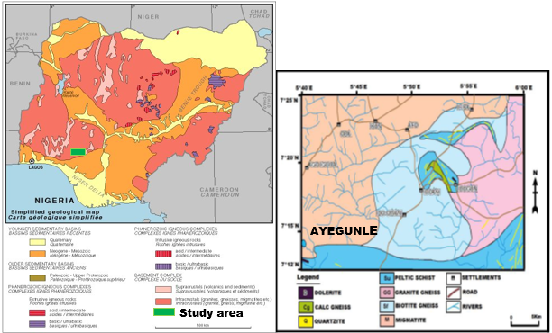

**Fig. 1:** Generalized Geological Map of Nigeria Showing Major Rock Suites (After Obaje, 2009).

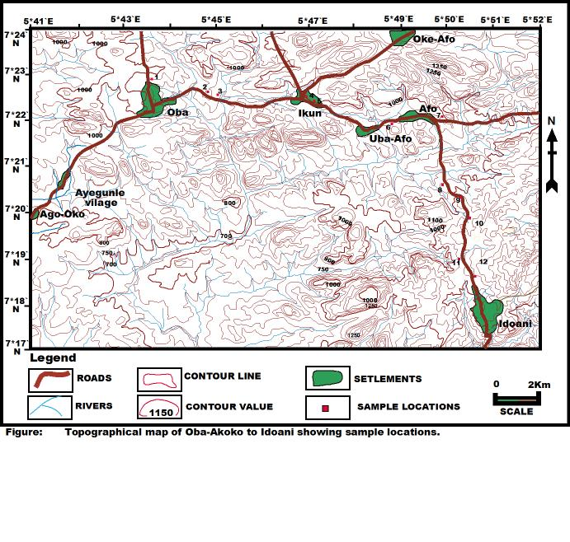

**Fig. 2:** Topographical Map of the Study Area Ayegunle Akoko.

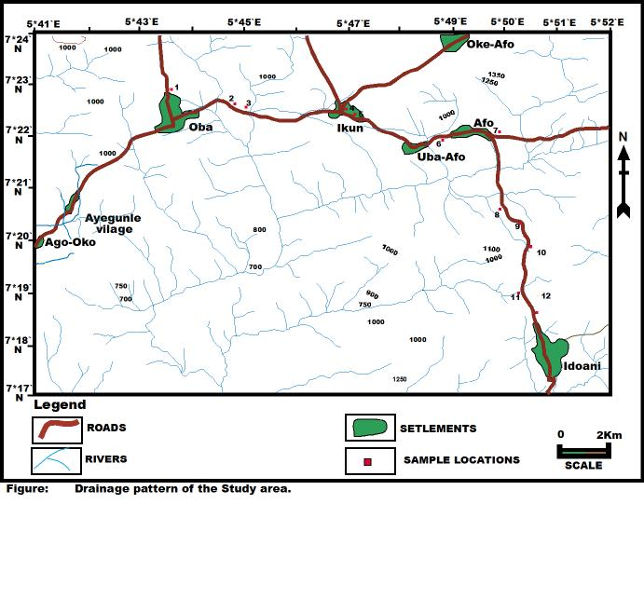

**Fig. 3:** Drainage Map and Sample Location of the Study Area.

1. Materials and methods

The equipment used is Geonics Slingram (EM34-3) and ABEM SAS1000C respectively, the instrument used in carrying out the geophysical methods include the following:

Slingram FDEM (EM34-3). Advanced frequency domain phase measuring electromagnetic system with mobile transmitter and receiver coils is 1m diameter and survey orientations are done horizontally and vertically. Vertical dipole was deployed in this study. The coils are cable-linked with reference signal that ensures that the coils separation distance of 10 to 100 m was sustained throughout the survey exercise. The Slingram transmitter and receiver is powered by direct current (DC) batteries and the receiver coil output goes through the compensator and decomposer. Slingram was first tested to adjust and calibrate the compensator to generate only the secondary fields that arises due to eddy currents generated in contact with anomalous conductive bodies and the compensated primary fields could generate the secondary fields. In electromagnetic alternating current is circulated along the ground surface, and the ground generated a primary electromagnetic current then induces alternating eddy current in any subsurface in the vicinity of its path; the alternating current, in turn, generated a secondary field which is detected by an electromagnetic receiver at the surface. The slingram was carried out perpendicular to the strike directions in 10 m distance separation of 100 m total distance. Twenty survey stations were established to delineate the presence of anomalous conductivity through its mutual inductance principle. The results generated from the receiver via the decomposer separate the secondary fields to percentage Real and Imaginary components of the primary fields. Electromagnetic fields are attenuated as they pass through the ground, and their amplitude decreases exponentially as depth increases. The depth of penetration "d" is defined as the depth at which the amplitude of the field Ad is reduced by a factor e-1 when compared to its surface amplitude. Ad= Aoe-1--in this case, d=303.8/, where d is measured in meters. The ground conductivity is measured in Sm-1, and the frequency of the fields is measured in Hz. As both the frequency of the electromagnetic field and the conductivity of the ground drop, the depth of penetration increases; as a result, the frequency utilized in an EM survey can be set to a desired depth range in any medium. The depth estimate measured was 50m, because of the 100 m total distance. Three crew members carried out the survey and precautions were taken to avoid appreciable errors arising from coplanar vertical dipole orientation and spacing. The results showed negative and positive anomalous conductive bodies which indicated sites for Vertical Electrical Sounding (VES) Schlumberger configuration survey points for groundwater exploration.

3.1. Frequency domain electromagnetic and electrical resistivity methods

Frequency Domain Electromagnetic (FDEM) vertical dipole profiling and Vertical Electrical Sounding (VES) were two complementary and widely used geophysical methods in the delineation of Precambrian Basement regolith and location of fissured media and associated deep weathering zones in crystalline terrains. Reconnaissance electromagnetic surveys are frequently employed to find aquiferous zones like fractures, faults, and joints (Palacky *et al,* 1981, Bernard and Villa 1991, Reynolds 1997, Kearey and Brooks 2002). As a result, such combinations can substantially aid in finding productive water in crystalline rock terrains. On the other hand, the VES offers data on the vertical change in electrical resistivity with depth. It's typically used to determine the validity of a feature identified through an EM survey.

The electrical resistivity approach was used to conduct a geophysical survey after that. The Schlumberger array was employed during the survey. The resistivity was determined as a function of depth commonly referred to as geo-electric sounding. The apparent resistivity is measured by systematically changing the electrode spacing. Vertical electrical sounding (VES) is a technique that involves probing a fixed location for depth.

1. Results and discussions

4.1. Result presentation of slingram FDEM

Traverses One to twenty:

Figures 4-7 show the plots of measured ground conductivity along transverse one on vertical dipole, using 10 m coil spacing cable (S-N). The highest point indicates high conductivity at the distance of 15- 50,60-80,15-50mS and 65- 100,50,15-20mS, 55-60,25, 35mS, 45-55, 30-59, 25-45,45-50, 35-40,37-100, 30-58, 10 -65, 30-65, 40-65, 10-52,10 -50 /70-100, 29-55, 35-55mS and the lowest conductivity at 50-60, 25,55-65,20, 70,65, 80, 80, 70, 30, 25,30 and 90,80, 20, 30 and 40,20 and 80,65,38-40,80-100 mS respectively.

|  |  |
| --- | --- |
| **(A)** | **(B)** |
| **C:\Users\HP\Desktop\Aye 2.PNG** | **C:\Users\HP\Desktop\gunle 1.PNG** |
|  |  |
| **(C)** | **(D)** |
| **C:\Users\HP\Desktop\Aye 2.PNG** | **C:\Users\HP\Desktop\gunle 2.PNG** |
|  |  |
| **(E)** | **(F)** |
| **C:\Users\HP\Desktop\Aye 3.PNG** | **C:\Users\HP\Desktop\gunle 3.PNG** |
|  |  |
| **(G)** | **(H)** |
| **C:\Users\HP\Desktop\Aye 4.PNG** | **C:\Users\HP\Desktop\VLF Dataonly\DISLIN.GIF** |
|  |  |
| **(I)** | **(J)** |
| **C:\Users\HP\Desktop\Aye 5.PNG** | **C:\Users\HP\Desktop\VLF Dataonly\EM Ayegunle 5a.gif** |

**Fig. 4:** (A-J) Profiles and Conductivities of Slingram Measurements

|  |  |
| --- | --- |
| **(A)** | **(B)** |
| **C:\Users\HP\Desktop\Aye 6.PNG** | **C:\Users\HP\Desktop\VLF Dataonly\EM Ayegunle 6a.gif** |
|  |  |
| **(C)** | **(D)** |
| **C:\Users\HP\Desktop\Aye 7.PNG** | **C:\Users\HP\Desktop\VLF Dataonly\EM Ayegunle 7a.gif** |
|  |  |
| **(E)** | **(F)** |
| **C:\Users\HP\Desktop\Aye 8.PNG** | **C:\Users\HP\Desktop\VLF Dataonly\EM Ayegunle 8a.gif** |
|  |  |
| **(G)** | **(H)** |
| **C:\Users\HP\Desktop\Aye 9.PNG** | **C:\Users\HP\Desktop\VLF Dataonly\EM Ayegunle 9a.gif** |
|  |  |
| **(I)** | **(J)** |
| **C:\Users\HP\Desktop\Aye 10.PNG** | **C:\Users\HP\Desktop\VLF Dataonly\EM Ayegunle 10a.gif** |

**Fig. 5:** (A-J) Profiles and Conductivities of Slingram Measurements.

|  |  |
| --- | --- |
| **(A)** | **(B)** |
| C:\Users\HP\Desktop\Aye 11.PNG | C:\Users\HP\Desktop\VLF Dataonly\EM Ayegunle 11a.gif |
|  |  |
| **(C)** | **(D)** |
| C:\Users\HP\Desktop\Aye 12.PNG | C:\Users\HP\Desktop\VLF Dataonly\EM Ayegunle 12a.gif |
|  |  |
| **(E)** | **(F)** |
| C:\Users\HP\Desktop\Aye 13.PNG | C:\Users\HP\Desktop\VLF Dataonly\EM Ayegunle 13a.gif |
|  |  |
| **(G)** | **(H)** |
| C:\Users\HP\Desktop\Aye 14.PNG | C:\Users\HP\Desktop\VLF Dataonly\EM Ayegunle 14a.gif |
|  |  |
| **(I)** | **(J)** |
| C:\Users\HP\Desktop\Aye 15.PNG | C:\Users\HP\Desktop\VLF Dataonly\EM Ayegunle 15a.gif |

**Fig. 6:** (A-J) Profiles and Conductivities of Slingram Measurements.

|  |  |
| --- | --- |
| **(A)** | **(B)** |
| C:\Users\HP\Desktop\Aye 16.PNG | C:\Users\HP\Desktop\VLF Dataonly\EM Ayegunle 16a.gif |
|  |  |
| **(C)** | **(D)** |
| C:\Users\HP\Desktop\Aye 17.PNG | C:\Users\HP\Desktop\VLF Dataonly\EM Ayegunle 17a.gif |
|  |  |
| **(E)** | **(F)** |
| C:\Users\HP\Desktop\Aye 18.PNG | C:\Users\HP\Desktop\VLF Dataonly\EM Ayegunle 18a.gif |
|  |  |
| **(G)** | **(H)** |
| C:\Users\HP\Desktop\Aye 19.PNG | C:\Users\HP\Desktop\VLF Dataonly\EM Ayegunle 19a.gif |
|  |  |
| **(I)** | **(J)** |
| C:\Users\HP\Desktop\Aye 20.PNG | C:\Users\HP\Desktop\VLF Dataonly\EM Ayegunle 20a.gif |

**Fig. 7:** (A-J) Profiles and Conductivities of Slingram Measurements.

**4.2.1. Presentation of results of electrical resistivity depth sounding curves**

The curves of depth sounding that typified the study area are classified into six type-curves based on the combination of layer resistivity. The type-curves are: H, A, QH, AA, HA, and HKH. Generally, they show a steeply rising terminal branch (Figs. 8-9 and Table 1) indicating an increase in apparent resistivity values with depth at large electrode spacing due to the effect of highly resistive underlying basement bedrock. The H-type and HKH-type curves are prevalent in the area and account for about 35.7% and 21.4%, respectively of the whole curves. These type-curves are followed by AA- and HA- type curves which account for about 14.3% each. The A- and QH- type curves are less common and account for about 7.1 % each. On the basis of similar features, the field type curves were divided into three groups (Olorunfemi *et al*. 2005). The frequency distribution of the various curve types in the study area is plotted on a pie chart (Fig.10). The percentage of their distribution varies from 5, 15, 20, 25, 30 percentages. Curve type HA is the most dominant curve while QH and HKH have the least percentage. Group 1 comprises H- and QH- type curves. Group 2 consists of HKH-type curve and Group 3 consists of HA-type curve. Group 1 is characterized by three-layer geoelectric sequence; the topsoil with variable lithology - sand, lateritic clay/sandy clay/clay, the second layer is composed of thick sandy unit or weathered/fractured bedrock which constitutes an aquifer and the bedrock as basal unit of infinite depth. On the other hand, Group 2 is typified by a five-layer geoelectric sequence comprising highly resistive topsoil, a relatively low resistive horizon, relatively high resistive underlies the latter, followed by low resistivity clay and basal high resistivity basement bedrock. Group 3 (HA-type curve), the geoelectric sequence is a four-layered type.

|  |  |
| --- | --- |
| **(A)** | **(B)** |
| C:\Users\HP\Desktop\Aye 1.PNG | C:\Users\HP\Desktop\aye 2.PNG |
|  |  |
| **(C)** | **(D)** |
| C:\Users\HP\Desktop\aye 3.PNG | C:\Users\HP\Desktop\aye ves 4.PNG |
|  |  |
| **(E)** | **(F)** |
| C:\Users\HP\Desktop\aye 5.PNG | C:\Users\HP\Desktop\aye 6.PNG |
|  |  |
| **(G)** | **(H)** |
| C:\Users\HP\Desktop\aye 7.PNG | C:\Users\HP\Desktop\aye ves 8.PNG |
|  |  |
| **(I)** | **(J)** |
| C:\Users\HP\Desktop\aye ves 9.PNG | C:\Users\HP\Desktop\aye ves 10.PNG |

**Fig.8:** (A-J)The Study Area's Typical Sounding Curves.

|  |  |
| --- | --- |
| **(K)** | **(I)** |
| C:\Users\HP\Desktop\aye ves 11.PNG | C:\Users\HP\Desktop\aye ves 12.PNG |
|  |  |
| **(M)** | **(N)** |
| C:\Users\HP\Desktop\aye ves 13.PNG | C:\Users\HP\Desktop\aye ves 14.PNG |
|  |  |
| **(O)** | **(P)** |
| C:\Users\HP\Desktop\aye 15.PNG | C:\Users\HP\Desktop\aye ves 16.PNG |
|  |  |
| **(Q)** | **(R)** |
| C:\Users\HP\Desktop\aye 17.PNG | C:\Users\HP\Desktop\aye 18.PNG |
|  |  |
| **(S)** | **(T)** |
| C:\Users\HP\Desktop\aye 19.PNG | C:\Users\HP\Desktop\aye 20.PNG |

**Fig.9:** (K-T) the Study Area's Typical Sounding Curves.

**Table 1:** VES Stations, Resistivities, Curve Types, Thicknesses and Depths of the Study Area

|  |  |  |  |  |  |
| --- | --- | --- | --- | --- | --- |
| Ves Station | No Of Layers | Resistivity (Ω-M) | Curve Type | Thickness (M) | Depth (M) |
| TR1V1 | 4 | 107/413/1794/1049 | HA | 1.8/7.7/64.4 | 1.8/9.21/74.0 |
| TR2V2 | 4 | 135/219/2423/1299 | HKH | 1.7/6.2/66.5 | 14/17.6/74.1 |
| TR3V3 | 4 | 81/166/1746/995 | KH | 0.8/7.6/66.5 | 0.8/8.5/74.9 |
| TR4V4 | 4 | 105/346/3674/1153 | HA | 3.0/2.9/53.5 | 3.0/5.9/59.4 |
| TR5V5 | 4 | 310/1086/1516/907 | H | 2.8/10.0/37.8 | 2.8/12.9/50.7 |
| TR6V6 | 4 | 480/315/1339/814 | H | 3.2/19.0/67.4 | 3.2/22.2/89.6 |
| TR7V7 | 4 | 142/180/1870/772 | HK | 1.0/27.1/76.9 | 1.0/28.2/105.1 |
| TR8V8 | 4 | 155/214/1006/694 | HK | 0.9/21.0/66.3 | 0.9/21.8/88.1 |
| TR9V9 | 4 | 488/174/1040/1625 | HK | 2.4/8.4/57.7 | 2.4/10.8/68.5 |
| TR10V10 | 4 | 134/185/1468/688 | H | 1.4/6.2/55.0 | 1.4/7.6/62.6 |
| TR11V11 | 4 | 146/479/893/707 | HK | 1.1/14.7/64.3 | 1.1/15.8/30.2 |
| TR12V12 | 4 | 150/436/720/612 | QH | 1.2/12.6/64.3 | 1.2/13.8/78.2 |
| TR13V13 | 4 | 179/566/688/703 | HA | 3.9/15.4/64.9 | 3.9/19.3/84.2 |
| TR14V14 | 4 | 101/471/1023/1037 | KH | 1.9/28.7/61.4 | 1.9/30.9/92.0 |
| TR15V15 | 4 | 101/712/458/521 | HA | 0.6/14.0/64.7 | 0.6/14.8/97.5 |
| TR16V16 | 4 | 119/184/689/960 | HA | 0.5/10.7/62.2 | 0.5/11.3/73.5 |
| TR17V17 | 4 | 169/440/972/802 | KH | 1.2/13.5/65.1 | 1.2/14.7/79.8 |
| TR18V18 | 4 | 1087/199/920/664 | HA | 1.4/8.1/39.9 | 1.4/9.6/49.5 |
| TR19V19 | 4 | 126/178/1080/663 | KH | 1.5/6.6/40.0 | 1.5/8.1/48.0 |
| TR20V20 | 4 | 151/280/777/603 | KH | 1.1/11.0/40.1 | 1.1/12.1/52.2 |

|  |  |  |
| --- | --- | --- |
| Curve type | Frequency | Percentage |
| H | 3 | 15% |
| HA | 6 | 30% |
| HK | 4 | 20% |
| HKH | 1 | 5% |
| KH | 5 | 25% |
| QH | 1 | 5% |

**Fig. 10:** Frequency Distribution Pie Chart of Observed Curve Types in the Study Area.

H Curve type: this curve type accounts for 15% of the study area and occurred in VES 5, 6, and 10. This implies that the first layer is greater than second layer, second layer is lesser than the third layer (ρ>ρ<ρ)

HA Curve type: HA curve type is the most dominant curve type observed in the study area. This curve type represents 30% frequency distribution and it appeared in VES 1,4, 13, 15, 16 and 18. The implication of the curve type is that fist layer is lesser than second layer, second layer is lesser than third layer, and third layer is lesser than fourth layer (ρ>ρ<ρ< ρ)

HK Curve type: It was observed that the HK- curve type appeared in VES 7, 8, 9 and 11; which accounted for 20% in the study area. This implies that the first layer is greater than second layer, second layer is lesser than the third layer, and the third layer is greater than the fourth layer (ρ>ρ<ρ> ρ)

HKH Curve type: This curve type represents 5% of its frequency distribution and it is observed in VES 5 only. This curve type revealed that first layer resistivity is lesser that the second layer, second layer greater than the third layer, and third layer lesser than the fourth layer (ρ<ρ<ρ> ρ< ρ)

KH Curve type: The KH curve type frequency distribution accounted for 25%, and is observed in VES 3,14, 17, 19, and 20. The curve type indicated first layer resistivity lesser than second layer, second layer greater than third layer, and third layer lesser than the fourth layer (ρ<ρ>ρ<ρ).

QH Curve type: The QH curve type frequency distribution accounted for 5% only and it is observed in VES 12. This curve type showed first layer resistivity greater than second layer, second layer greater than third layer, and third layer lesser than the fourth layer (ρ>ρ>ρ<ρ).

**4.2.2. The geoelectric sections**

With the help of borehole lithological logs, three unique subsurface geologic strata were determined from the geoelectric sections. Topsoil with varying moisture content, clay/sandy clay/clayey weathered column, and bedrock are among the geoelectric layers.

1. Topsoil: The topsoil is primarily clay/sandy clay/clayey sand, with some coarse-grained dirty sands and lateritic column. Resistivity values ranging from 42 to 1098 Ώm describe the layer (Fig. 12). Wide textural/compositional heterogeneity in the topsoil may be the source of this variation (Olayinka and Olorunfemi, 1992; Olorunfemi and Okhue, 1992, Olayinka *et al.*2004). Clay has a resistivity of less than 100 ohm-m, but lateritic sand has a resistivity of more than 1000 Ώm, as shown on the study area's eastern flanks. The topsoil thickness varies from 1.1 to 4.1 meters, with a mean thickness of 2.0 meters. The variance in thickness may have been impacted by local topographical highs on the eastern flanks and lows on the western flanks in the area. The unit is less hydro geologically appealing due to the generally thin nature of the topsoil and a relatively low degree of groundwater saturation.
2. Clay/sandy clay/weathered/partially weathered column: The layer directly underlying the topsoil (see Fig. 12) consists of clay materials. The layer's resistivity ranges from 26 to 866 m. Resistivity levels less than 100 m may indicate clay, whilst values greater than 150 Ώm may indicate clayey sand/sand. The clayey zones indicate a porous yet impermeable medium with a restricted capacity to deliver groundwater to wells. This layer's thickness ranges from 2.6 to 24.2 m. The vast range of thicknesses found could be attributed to the irregular geography of the basement bedrock.
3. Basement bedrock: The resistivity values in the third layer are often higher than 1000 Ώm, suggesting fresh basement bedrock. It is characterized by uneven topography and has infinite thickness.
4. Geo-electric section along Traverses 1-7

The geo-electric segment of Traverse 1-7 from east to west is depicted in Fig.11. In 1-2,5-7, four major geologic units were identified: topsoil, weathered layer, fractured Basement, and fresh Basement, while 3-4 had no fractured Basement. The resistivity of the topsoil and its deep thicknesses is in the range of 108 – 1049 Ώm, 135 – 1299 Ώm, 81 – 986 Ώm, 105 – 1153 Ώm, 310 – 907 Ώm, 488 – 814 Ώm, 143 – 773 Ώm, and thickness lateritic, clayey, sandy clay, clayey sand, or sand is thought to be the first layer. The resistivity values of the weathered layers and their depth thicknesses beneath the topsoil range from 413–1794 Ώm, 219–2423 Ώm, 81–163 Ώm, 346–367 Ώm, 310–1086Ώm, 315–1339 Ώm, and 1.8–9.4m, 6.2–7.6m, 1.6 The resistivity of the broken basement and its depth thicknesses is in the range of 1794 – 1049 Ώm, 219 – 691 Ώm, 1516 – 907 ohm-m, 315 Ώm, 1870 – 773 Ώm, and 4.0 - 12.4m, 5.8 – 15.8m, 2.8 - 12.9m, 19m, 1.0 – 28.2m.The resistivity values of the fresh Basement and depth to bedrock range from 1,282 ohm-m to 1299- ∞ Ώm to 1746 - ∞ Ώm, 367 - 1153 Ώm to 907 Ώm to 1339 Ώm to 773 Ώm and 64.5 – 74m, 7.6 – 74.1m, 0.8 – 8.5m, 5.9 – 59 Thus, the bedrock topography along traverses 1-7 is such that there is a notable depression along VES 2. Fragmented basement and weathered basement are potential weak zones, and there is thin overburden in VES 3-4 on the traverses' western edge.

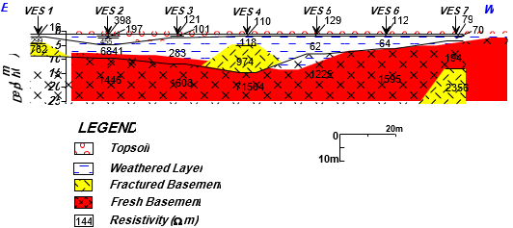

**Fig. 11:** Geo-Electric Section in E – W Direction, Along Traverse 1 to 7 of the Study Area.

1. Geo-electric section along Traverses 8-12

Fig.12 shows the geo-electric segment along traverses eight to twelve. The topsoil, weathered layer, fractured basement, and fresh basement were identified as the four major geologic units. The resistivity of the topsoil ranges from 155 to 964 m, 488 to 1625 Ώm, 134 to 688 Ώm, 146 to 707 Ώm, and 150 to 612 Ώm, with depth thicknesses of 1.4, 2.4, 1.4, 1.1, and 1.2m. Lateritic, clayey, sandy clay, clayey sand, or sand is thought to be the first layer. The weathered layer beneath the topsoil exhibits resistivity values of 214 Ώm, 1742 –1040 Ώm, 413 –1794 Ώm, 499 Ώm, 436 Ώm, and depth thicknesses of 21 m, 8.4 m, 6.2 m, 14.7 m, and 126 m. The resistivity of the cracked Basement ranges from 1794 to 1049 Ώm.1742 – 1040 Ώm,1463 – 688 Ώm,893 – 707 Ώm,720 – 612 Ώm, depth thicknesses ranges of 2.8m, 55m, 15m, 13m.The resistivity values of the fresh basement 1006 Ώm, 1,625 - ∞ Ώm, 688 - ∞ Ώm, 707 ∞ Ώm. 720 Ώm, depth to bedrock values are 88.1m, 68.5m, 62.6 – 74m, 80.2m, 78.2m.Thus, the bedrock topography along the traverse eight is such that there is a rocky outcrop that is very prominent beneath VES 8.

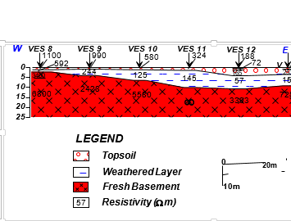

**Fig. 12:** Geo-Electric Section in E – W Direction, Along Traverse 8 to 12 of the Study Area.

1. M Geo-electric section along Traverses 13-20

Fig. 13 depicts the geo-electric section, which displays four basic geologic units: topsoil, weathered layer, fractured basement, and fresh basement.

The resistivity of the topsoil ranges from 179 to 703 Ώm, 101 to 1037 Ώm, 101 to 521 Ώm, 119 to 460 Ώm, 108 to 1049 Ώm, 169 to 802 Ώm, 129 to 664 Ώm, 151.7 to 603.8 Ώm, and depth thicknesses of Lateritic, clayey, sandy clay, clayey sand, or sand is thought to be the first layer. Resistivity values in the weathered layer beneath the topsoil range from 506–668ohm-m, 413–1794Ώm, 712–458Ώm, 184–689Ώm, 413–1794Ώm, 440–972Ώm, 440–974Ώm, 280.8–11.8Ώm, and depth thicknesses of 15.The fractured basement has resistivity values in the range of 668 ohm-m, 471– 1023 Ώm, 1794 – 1049 Ώm, 521 Ώm, 689 – 460 Ώm, 1794 – 1049 Ώm, 972 – 802 Ώm, 1081 – 664 Ώm, 777 – 603 Ώm at the depth ranges of 4.0 - 12.4m, 11.0 – 62.2m 4.0 - 12.4m, 14m, 79.5m, 11.0 – 62.2m, 4.0 - 12.4m, 4.0 - 12.4m, 4.0 - 12.4m.The resistivity values of the fresh basement is 703 - ∞ Ώm, 1,037 - ∞ Ώm, 521 Ώm, 460 - ∞ Ώm, 1,282 - ∞ Ώm, 802 - ∞ Ώm, 48 - ∞ Ώm, 603 Ώm and depth to bedrock values are 84.2m, 92m, 79.5m, 64.5 – 74m, 64.5 – 74m, 65.1 – 79.8m, 40 – 48m, 40 – 52.2m.Therefore, the bedrock topography along the traverse one is such that there is a depression that is very prominent beneath VES 17 and 20.

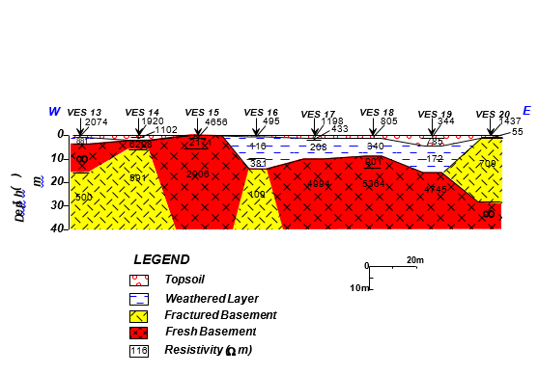

**Fig. 13:** Geo-Electric Section in W – E Direction, Along Traverse 13 -20 of the Study Area.

General observations show that the bedrock topography is uneven (undulating) across the study area. The differential settlements observed on the walls of the buildings in the area were precipitated by the variations in the thicknesses of the overburden observed in the interpreted results.

1. Discussion

The electromagnetic and vertical electrical sounding survey was conducted in mapping of the subsurface geologic structures so as to delineate their trend and distribution across the study area, Ayegunle / Oka Akoko, Ondo State. The acquired data were processed qualitatively and quantitatively as results were duly presented as profiles, maps and inversions. Some selected points were sounded along the traverses using the Vertical Electrical Sounding techniques in order to establish the information obtained with the EM34-D data acquired. The interpretation of the electromagnetic generated profiles was based on the identification of linear conductive features, using colour code on the colour scale bar generated along with the Slingram FDEM vertical dipole profiles. The conductive character of the subsurface was indicated by the spots where the raw real inflection intersected the positive peak of the filtered real. These were determined using a 2-D inversion model created with Karous-Hjelt filtering software (actual component, unnormalized), with colour codes references below the profiles, with black representing areas of highest resistivity and red indicating areas of maximum conductivity.

1. Conclusion

In the research area, the use of a combination of electromagnetic profiling and vertical electrical resistivity approaches has helped to improve understanding of groundwater occurrence in the Ayegunle/Oka Akoko basement complex in southern Nigeria. Geoelectric subsurface information produced from the interpretation results of vertical electrical soundings corroborated geological structures assumed to represent basement fractures (zones of high conductivities) detected from VLF-EM anomaly curves. The VES interpretation result identified three (3) major subsurface geoelectric layers: topsoil (usually sandy), clay sandy or partially weathered layer, and basement (fractured/fresh basement). Interpretation of VLF-EM and electrical resistivity sounding results enabled identification of suitable site for productive borehole and groundwater in a typically crystalline terrain as indicated in the study area. The groundwater potential map shows a reliable agreement with the groundwater discharge from existing boreholes within the study area. Above all, the development of some of the sites investigated (VES 1-20) will encourage the dwellers to adopt irrigation farming, thereby improving their socio-economic and agricultural status.

Conflicts of interest

The authors declare that there are no conflicts of interest in this research work

References

1. Barker RD (2007) Electrical resistivity methods for borehole siting in hardrock region. In: Thangarajan M (ed) Groundwater: resource evaluation, augmentation, contamination, restoration, modeling and management. Springer, Dordrecht, p 357 <https://doi.org/10.1007/978-1-4020-5729-8_2>.
2. Bayewu OO, Oloruntola MO, Mosuro GO, Watabuni FG (2012) Groundwater exploration in Ago-Iwoye Area of Southwestern Nigeria, using Very Low Frequency Electromagnetic (VLF-EM) and Electrical Resistivity methods. Int. Journal of Applied Sciences and Engineering Research, 1(3): 2277 – 9442 <https://doi.org/10.6088/ijaser.0020101046>.
3. Bosu JK (2004) Groundwater Exploration in the Granitic Basement in the Assin District of the Central Region Using the Electrical Resistivity Method. MSc thesis submitted to the College of Science, Kwame Nkrumah University of Science and Technology, Kumasi, 2004. http://hdl.handle.net/123456789/1872. Date assessed: September 10, 2015.
4. Kearey P, Brooks M (2002) An Introduction to Geophysical Exploration. Third Edition, Blackwell, London. Publishing, 3rd edn. pp.255.
5. Obaje NG (2009) Geology and Mineral Resources of Nigeria. Springer, Dordrecht Heidelberg London New York, 221 p <https://doi.org/10.1007/978-3-540-92685-6>.
6. Okhue ET, Olorunfemi MO (1991) Electrical resistivity investigation of a typical Basement Complex area. The Obafemi Awolowo University campus case study. J. Mining Geol., 2 (27):63-69.
7. Okpoli CC, Ozomoge P (2020) Groundwater exploration in a typical Southwestern Basement terrain NRIAG Journal of Astronomy and Geophysics 9(1): 289-308 <https://doi.org/10.1080/20909977.2020.1742441>.
8. Oladunjoye HT, Odunaike RK, Ogunsola P, Olaleye OA (2013) Evaluation of groundwater potential using electrical resistivity method in Okenugbo area, Ago - Iwoye, southwestern, Nigeria. International Journal of Engineering and Applied Sciences, 4(5): 22-30.
9. Olayinka AI, Amidu SA, Oladunjoye MA (2004) Use of Electromagnetic Profiling and Resistivity Sounding for Groundwater Exploration in the Crystalline Basement Area of Igbeti, Southwestern Nigeria. Global Journal of Geological science.2(2):243-253 <https://doi.org/10.4314/gjgs.v2i2.18701>.
10. Olayinka AI, Olorunfemi MO (1992) Determination of Geoelectric Characteristics in Okene Area and Implications in Borehole Sitting, Journal of Mining and Geology, 28(2):403-412.
11. Olorunfemi MO, Fatoba JO, Ademilua LO (2005) Integrated VLF-Electromagnetic and Electrical Survey for Groundwater in a crystalline Basement Terrain of Southwest, Nigeria. Global Journal of Geological sciences, 3(1): 71-80 <https://doi.org/10.4314/gjgs.v3i1.18714>.
12. Omosuyi GO, Ojo JS, Enikanselu PA (2003) Geophysical Investigation for Groundwater around Obanla-Obakekere in Akure Area within the Basement complex of South-Western Nigeria. Journal of Mining and Geology. 23: 305-310 <https://doi.org/10.4314/jmg.v39i2.18799>.
13. Onyekwelu CC, Onwubuariri CN, Mgbeojedo TI, Al‑Naimi LS, Ijeh BI, Agoha, CC (2021) Geo‑electrical investigation of the groundwater potential of Ogidi and environs, Anambra State, South‑eastern Nigeria, Journal of Petroleum Exploration and Production 11:1053–1067, <https://doi.org/10.1007/s13202-021-01119-z>.
14. Palacky GJ (1987) Clay Mapping Using Electromagnetic Methods. First Break, 5:295 – 306 <https://doi.org/10.3997/1365-2397.1987015>.
15. Rahaman MA (1989) Review of Basement Geology of Southwestern Nigeria. In Geology of Nigeria (Kogbe, C./Ed). Elizabethan publication Co. Nigeria 41 – 58.
16. Reynolds JM (1997) An Introduction to Applied and Environmental Geophysics. John Wiley and Sons Ltd.
17. Rosen S, Vincent JR (1999) Household Water Resources and Rural Productivity in Sub- Saharan Africa: A Review of the Evidence. Development Discussion Paper No. 673, Harvard Institute for International Development, Harvard University.
18. WHO/UNICEF (2000) Global Water Supply and Sanitation Assessment 2000 Report, New York, Geneva: Joint Monitoring Programme for Water Supply and Sanitation (JMP).