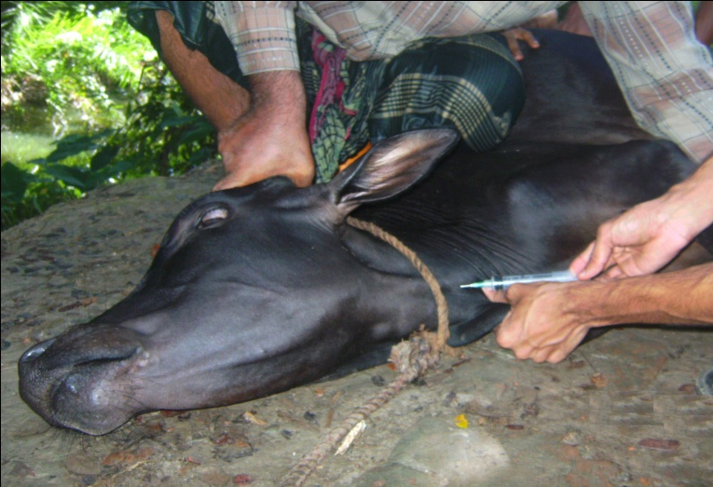

Photograph 1: Collection of blood from jugular vein

