Supplementary Figures
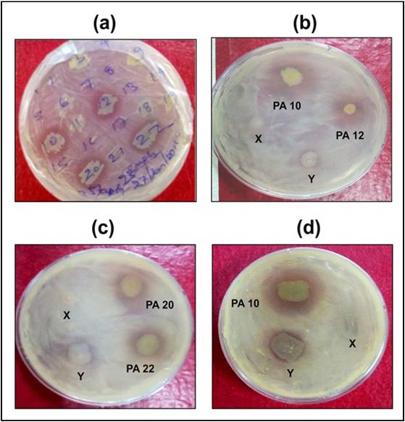
Figure S1
Antibacterial activity observed against the growing lawns of, (a) Staphylococcus aureus, (b, c) Mycobacterium abscessus, (d) Mycobacterium smegmatis. (X=PA BAA 427, Y=PA 28753)

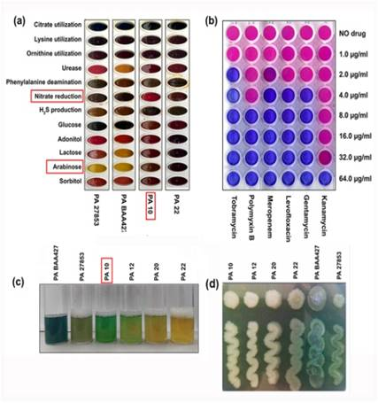
Figure S2
(a)Biochemical characterization of the bioactive strains (b) Antibiotic Susceptibility profile; Blue colored wells are showing the bacterial killing at the corresponding concentration of antibiotic drugs. The pink color wells represent the unaffected or live cells. (c) pigment production after 12 hour (d) Colony morphology

