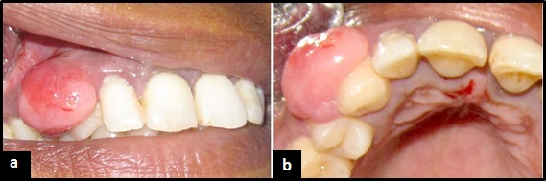

Fig. 1: (a &b) Clinical photograph of oral focal mucinosis involving the right maxillary canine region

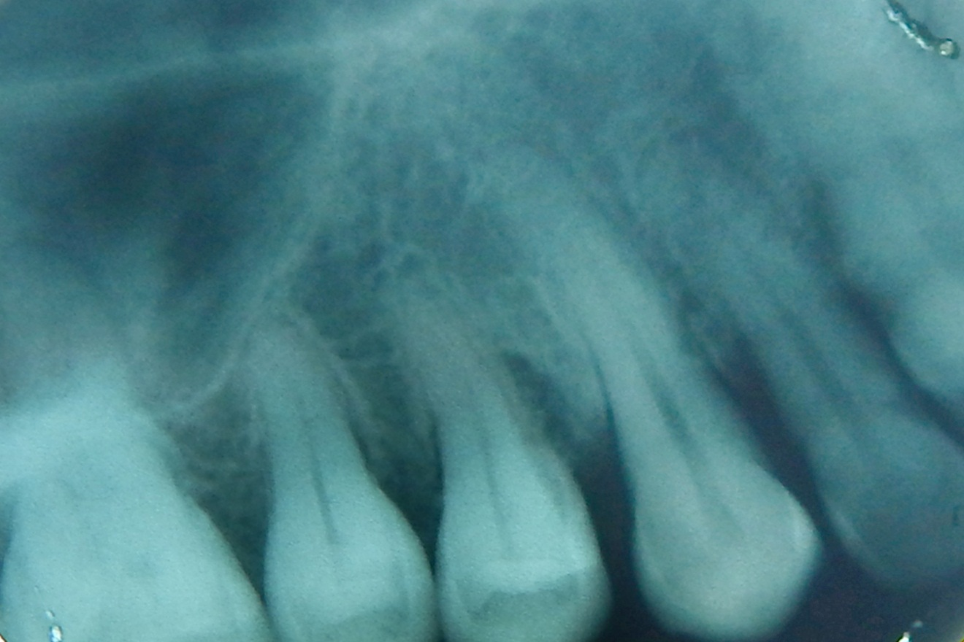

Fig. 2: Intra Oral Periapical Radiograph showing mild vertical interdental bone loss between 13 and 14 and horizontal interdental bone loss between 12 and 13.

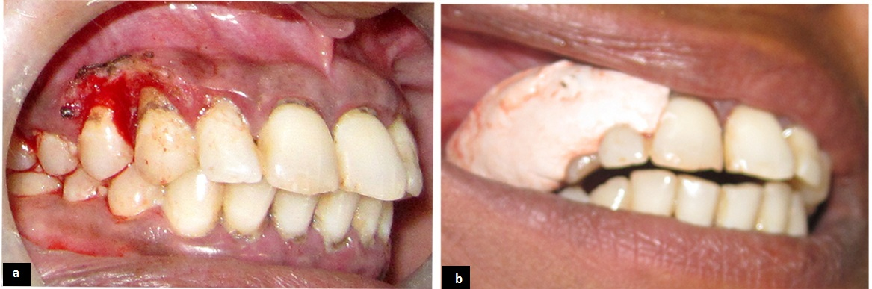

Fig. 3: (a) Surgical excision of lesion done using electrocautery (b) Periodontal pack was placed
after excision

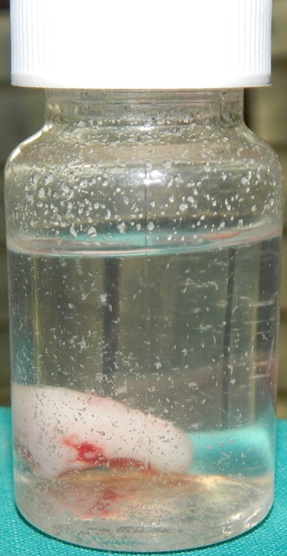

Fig. 4: Excised lesion stored in formalin

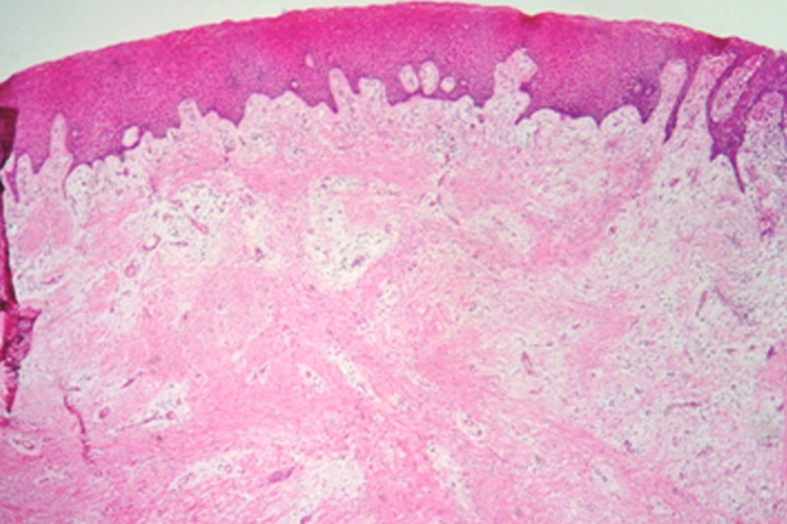

Fig. 5: Microscopic examination shows fibrocellular connective tissue with stellate shaped fibroblasts

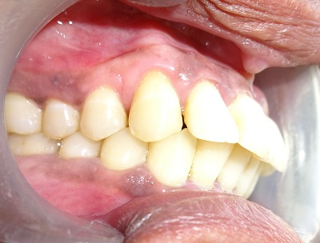
Fig. 6: Post operative photograph which shows no signs of recurrence at 6 month follow up

