Figure and ligands:

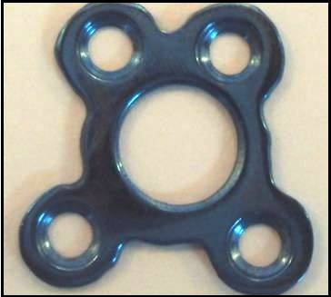
Figure 1. 3-D titanium condylar trapezoidal osteosynthesis plate (orthomax )

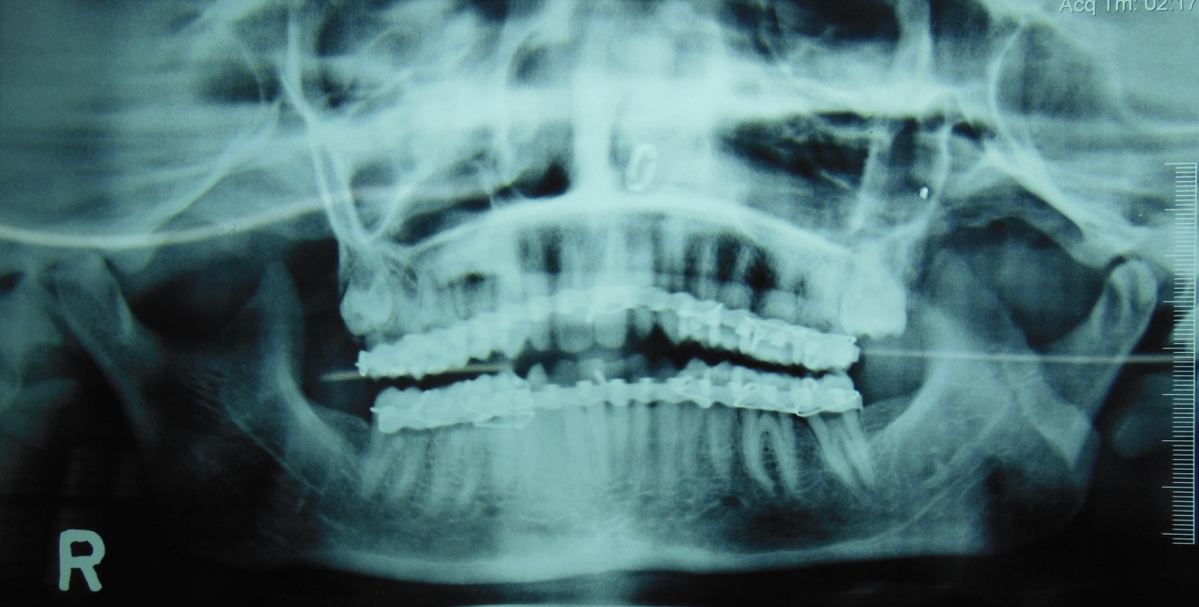
Figure 2. Pre operative O.P.G x ray showing fracture left subcondyle

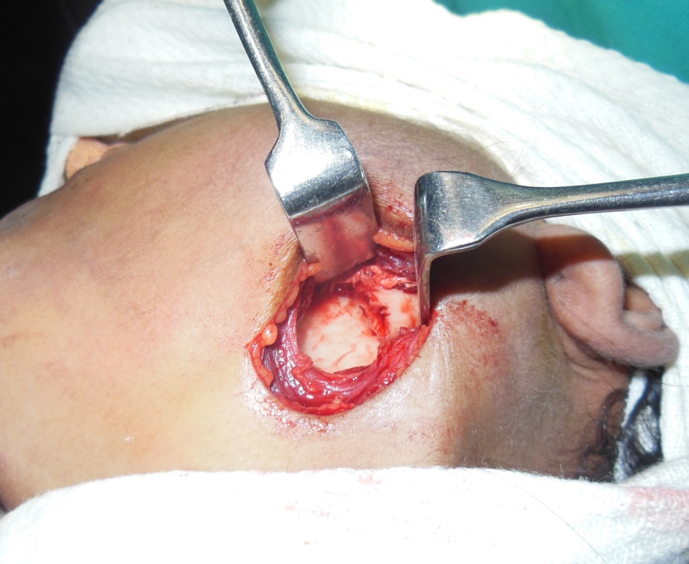

Figure 3. Surgical exposure of fracture site

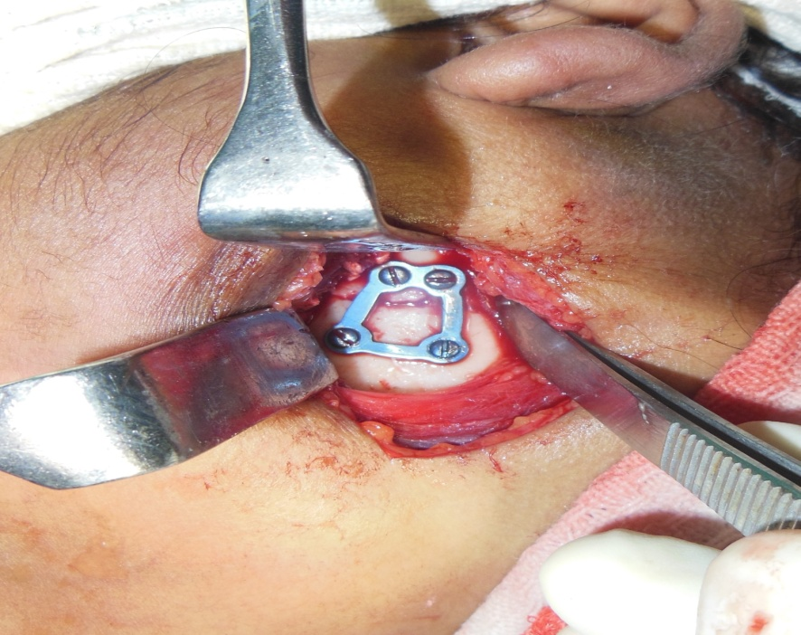

Figure 5. Reduction and plate fixation

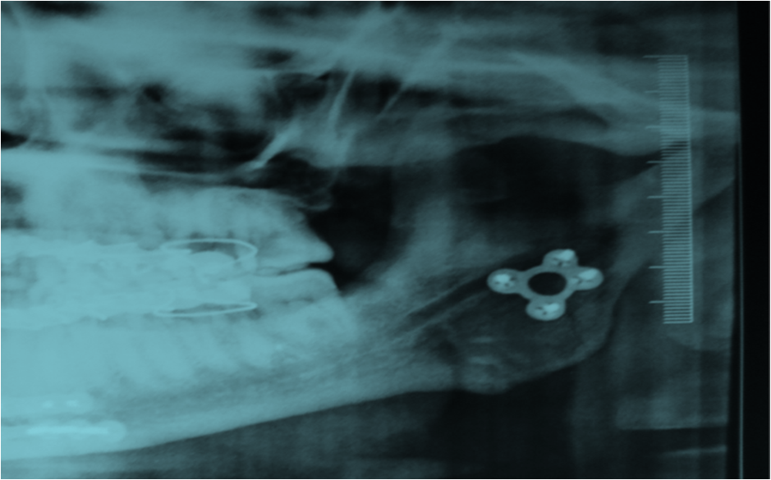

Figure 5. Post operative OPG

