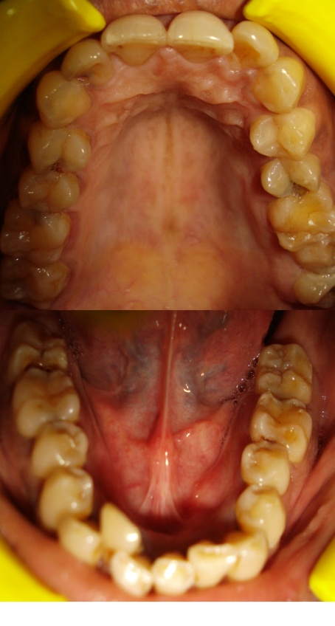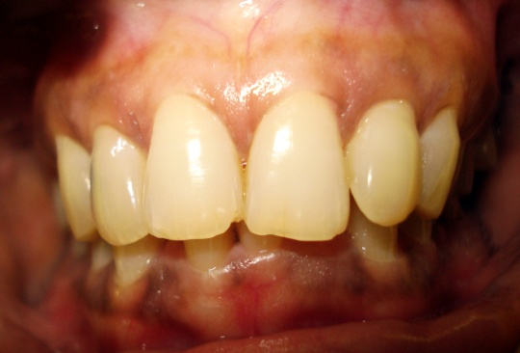**FIGURES**

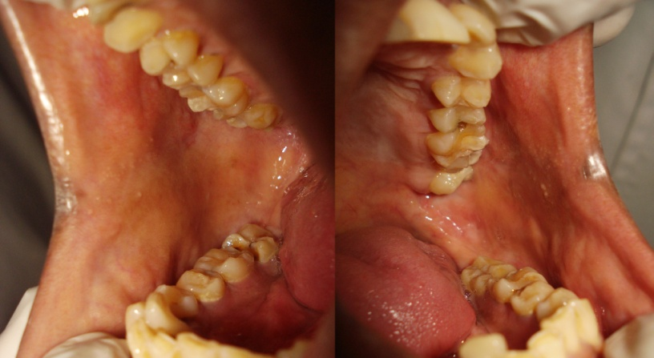

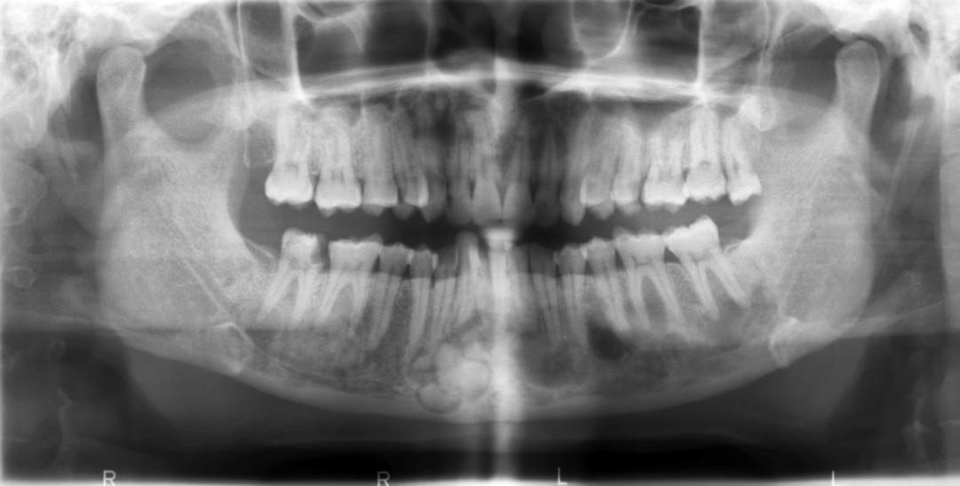

Pictures showing no gross abnormality in the jaws clinically

Figure 1:- Orthopanoramic image showing multiple radiopacities in all the quadrants of both the jaws and a well defined radiopacity in the anterior mandible surrounded by irregular radiolucent border

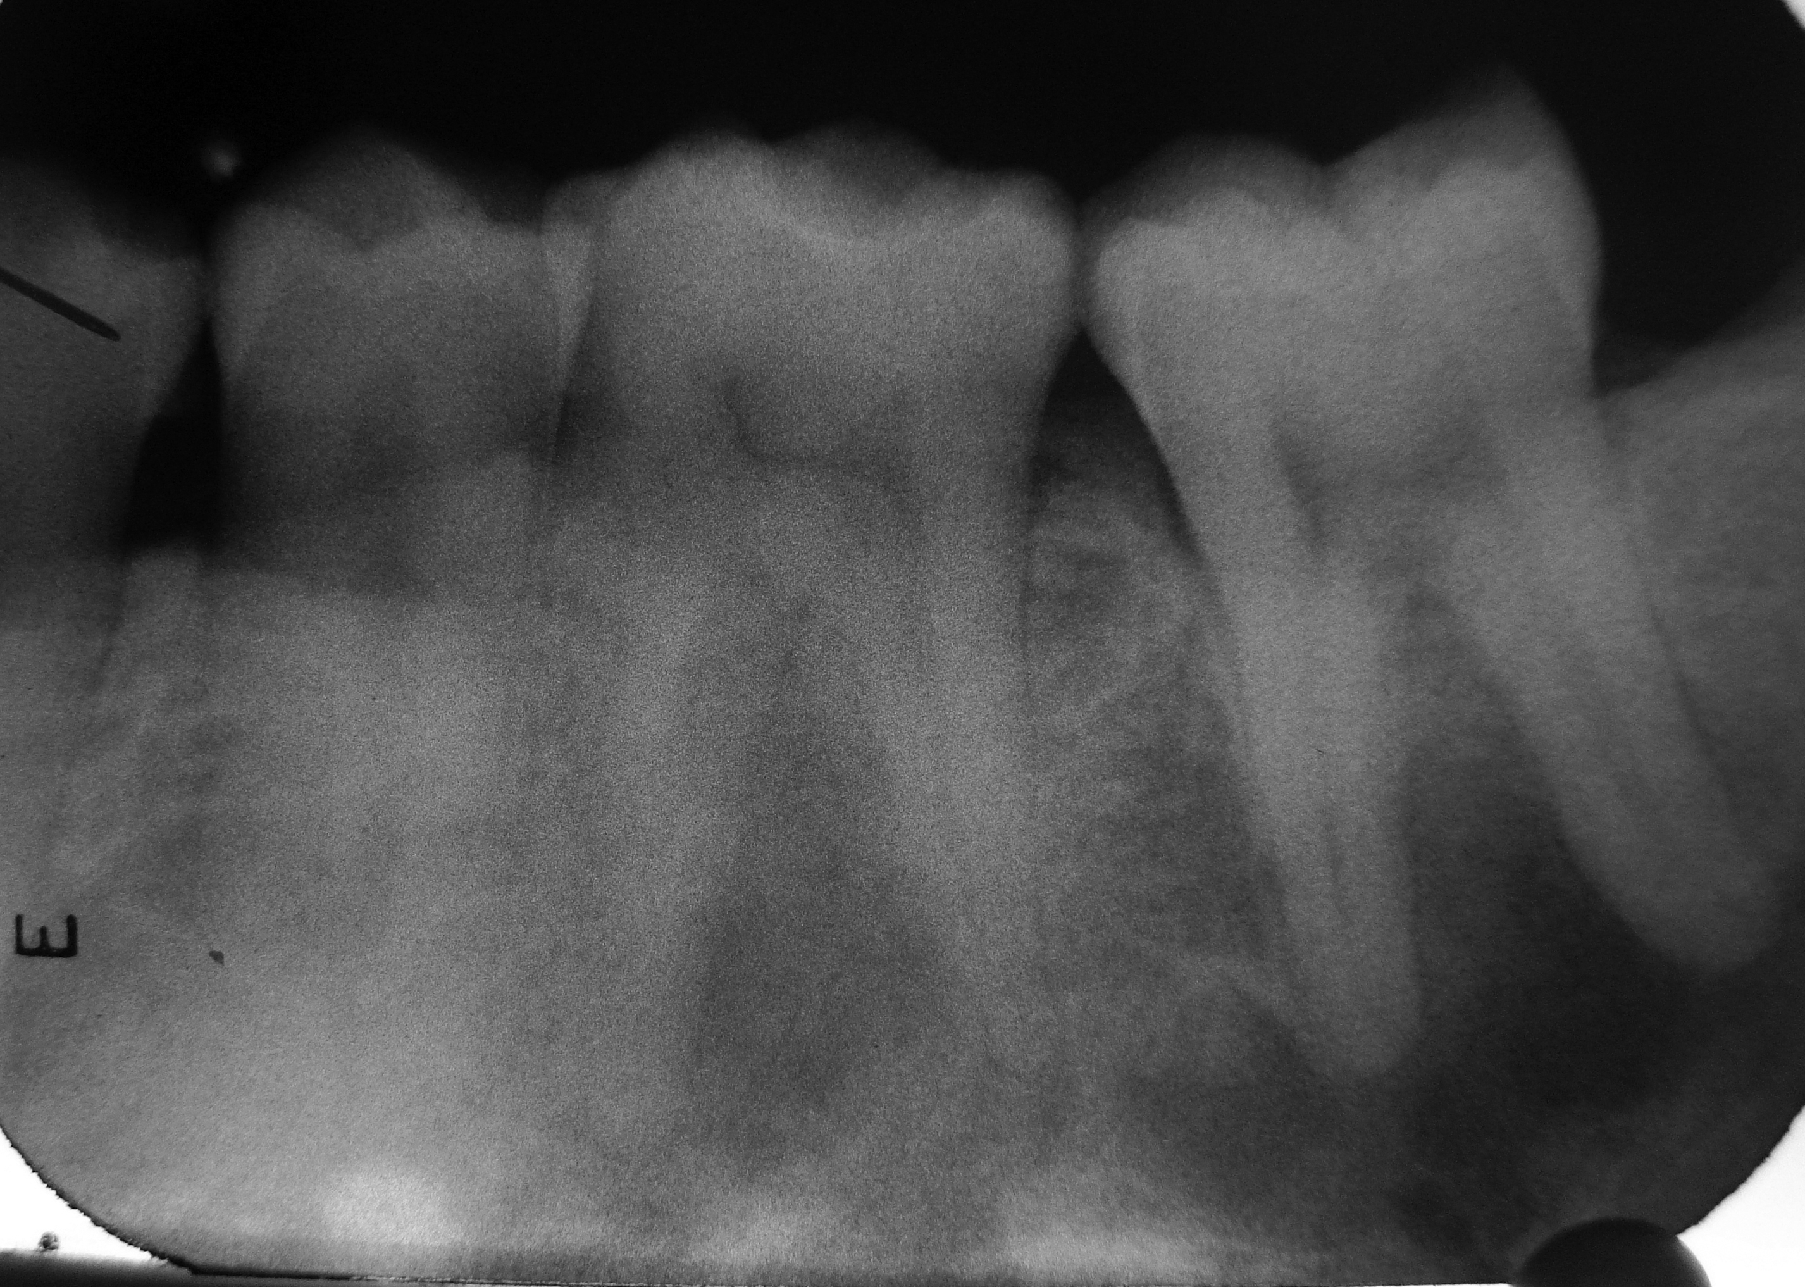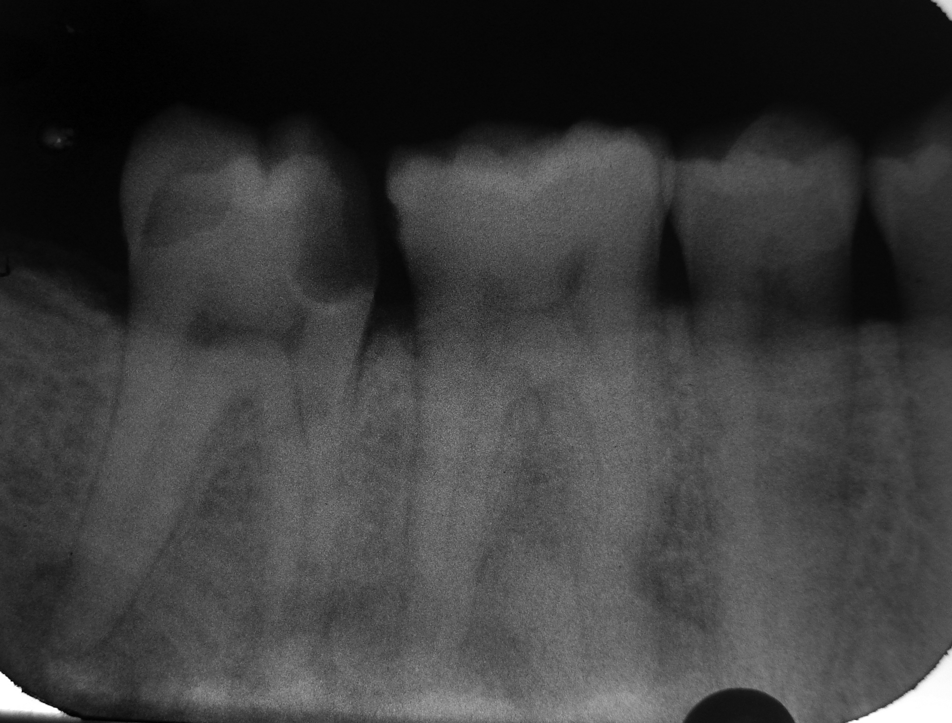

Figure2, 3:- Intra oral periapical radiographs showing multiple mixed radiolucent-radiopaque lesions corresponding to the periapical areas of the teeth with intact lamina dura, at a level above the inferior alveolar canal.