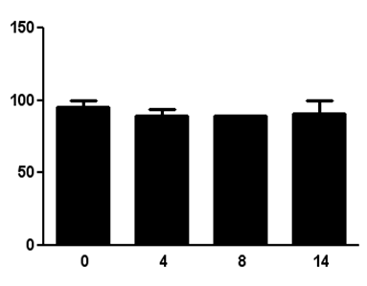
Blood Glucose
Blood Glucose (mg/dl)
Days
Figure 1: Blood glucose measurement in glucose fed animals. There was no significant drop in the blood glucose of the animals fed with glucose food and water during insulin treatment. Thus the euglycemic condition was achieved. Values are mean ± SEM (N= 18).

Figure 2: Effect of subcutaneous administration of insulin on blood pressure in awake animals. Animals were treated with subcutaneous injections of humulin and provided with glucose food. Mean arterial pressure (MAP), Systolic blood pressure (SBP) and Diastolic blood pressure (DBP), was monitored over a period of 2 weeks with tail cuff analysis post insulin injections. There was no significant difference observed. Values are mean ± SD (N= 10).

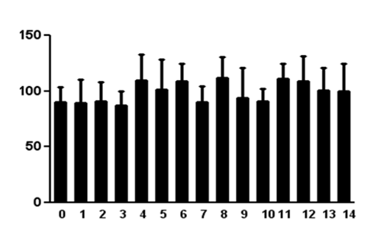
ATP
(a)

Concentration of ATP (ng/μl)

Days

(b)

Figure 3: Analysis of ATP and Ang II. In awake rats, physiological saline was perfused through the microdialysis probes inserted in kidneys. Perfusate was collected post insulin (7Units/kg) injections continuously for 9 hr during 2 weeks period while providing glucose diet. Samples were then analyzed for (a) ATP using luciferin-luciferase assay and (b) AngII using EIA. There was no significant difference in either ATP or Ang II levels from day 0 through day 14. Values are mean ± SEM (N= 8).
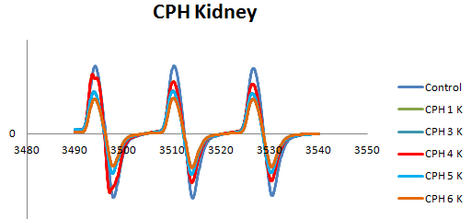
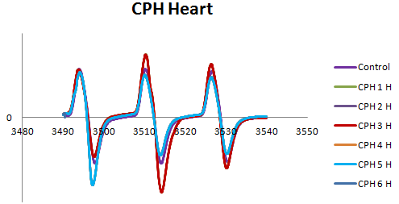
Magnetic Field (Gauss)
Intensity (arbitrary units)
Magnetic Field (Gauss)
(a)
(b)
Intensity (arbitrary units)

Figure 4: Detection of superoxide and peroxynitrite. EPR spectroscopy of (a) kidneys and (b) hearts collected on 14th day of insulin treatment were incubated for 60 min with CPH.

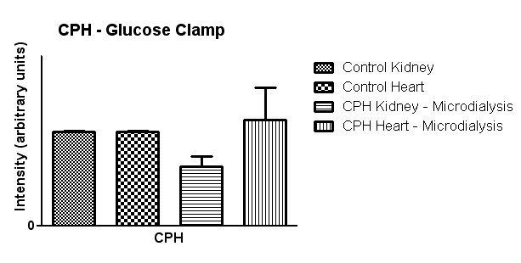

Figure 5: Detection of superoxide and peroxynitrite. Representative bar graphs indicate the oxidative stress produced in kidney and heart when treated with CPH to detect superoxide and peroxynitrite. Maintenance of euglycemia reduced the superoxide and peroxynitrite levels in kidney but not significantly when compared with control CPH. There was no significant change observed in superoxide and peroxynitrite production. Values are mean ± SEM (N= 8).

Insulin treatment
Renal interstitial ATP, Ang II
ROS, RNS
Glucose clamping
Oxidative stress
Hypertension
? Renal Damage

Figure 6: Effects of glucose clamping. This figure summarizes the study. Recurrent insulin injections promote hypoglycemia which can be normalized by glucose clamping. External glucose supplement attenuates renal interstitial ATP and Ang II elevations. Reduced oxidative stress was also observed by blunted ROS and RNS levels. Glucose clamping maintained euglycemic conditions which resulted in almost normal blood pressure which might attenuate diabetes associated renal end organ damage.

