Fig. (5): A slide of an adult rat intestine in (Group I) shows that a few PCNA positive cells (brown coloration) were observed in the crypt regions (yellow arrows) (low expression) (strept -Avidin -Biotin, X40).
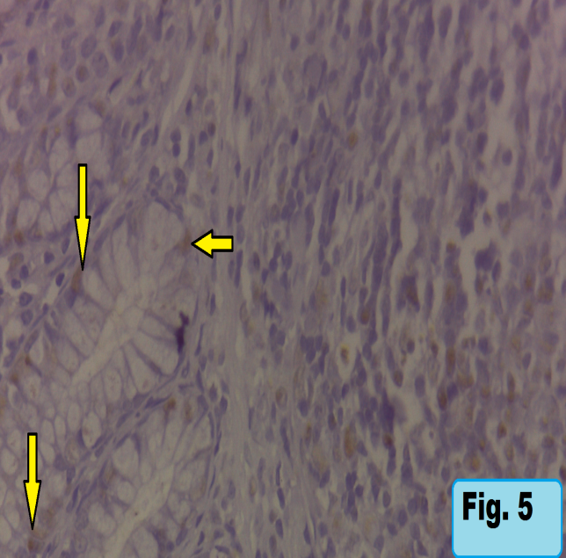
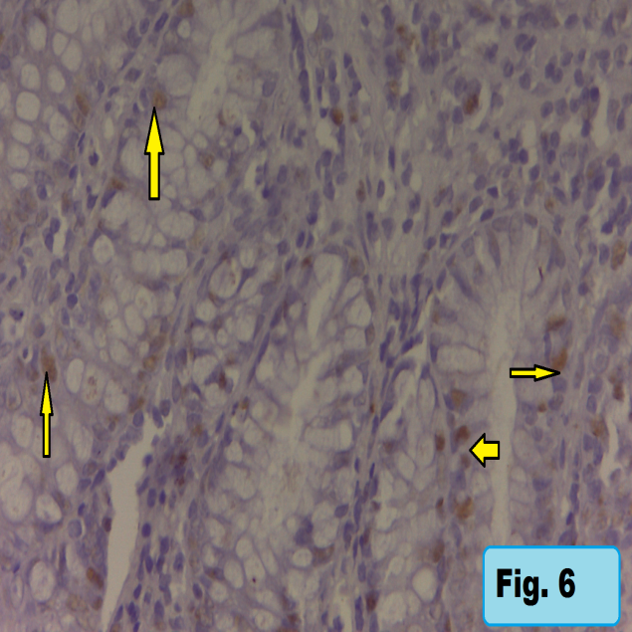
Fig. (6): A slide of an adult rat intestine in (Group II) shows that a few PCNA positive cells (brown coloration) were observed in the crypt regions (yellow arrows) (low expression) (strept –Avidin-Biotin,X40).
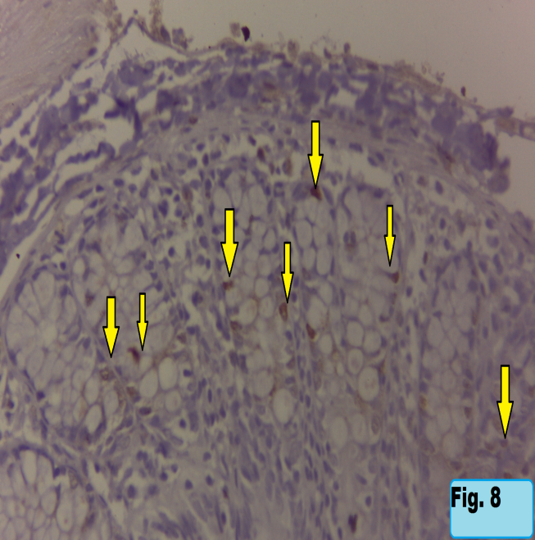
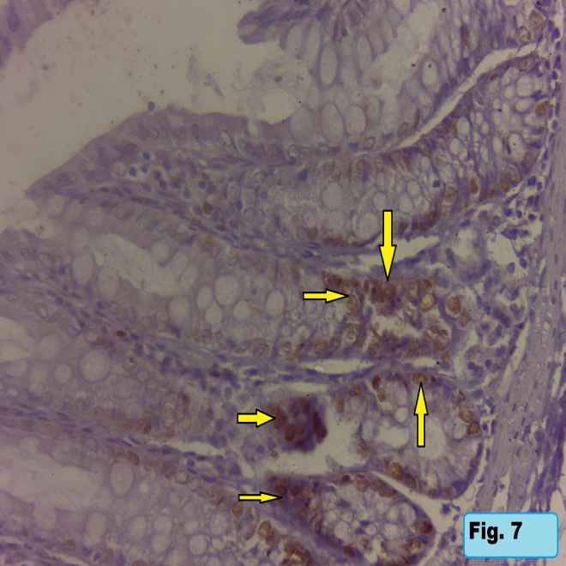

Fig. (7): A slide of an adult rat intestine in (Group III) shows the number of PCNA positive cells (brown coloration) was highly increased in the crypt regions (yellow arrows) (high expression) (strept -Avidin -Biotin, X40).

Fig. (8): A slide of an adult rat intestine in (Group IV) shows that concomitant administration of GTE with NaF markedly decrease the number of PCNA positive cells (brown coloration)(yellow arrows) (moderate expression) (strept -Avidin -Biotin, X40).

