Figures
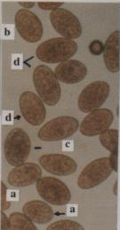 |  | 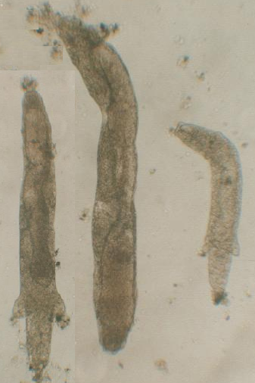 |  | 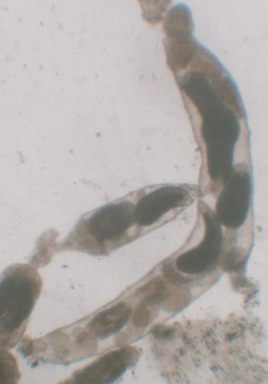
(Fig. 1-A) |  | (Fig. 1-B) |  | (Fig. 1-C)
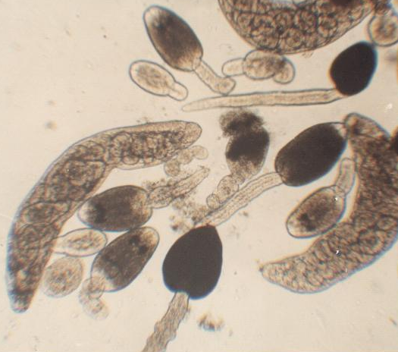 |  |  | 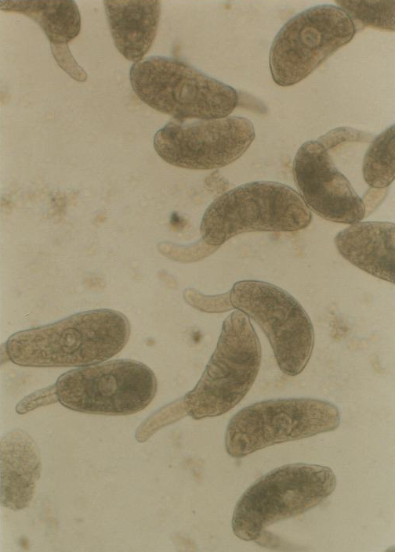 |  |  | 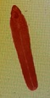
(Fig. 1-D) |  |  | (Fig. 1-E) |  |  | (Fig. 1-F)
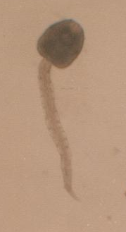 | 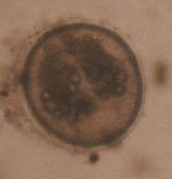 |  |  |  | 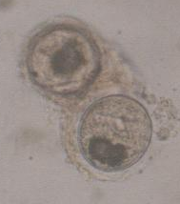
(Fig. 1-G) | (Fig. 1-H) |  |  |  | (Fig. 1-I)

Fig. (1):-Eggs and parthenitae extracted from examined laboratory and field collected snails (fresh non mounted specimens)
(1-A)- Fasciola eggs of different sizes, very small (a), medium spherical (b), elongated (c) and large one (d) present in one field collected and purified from stool (X 125)
(1-B)– Three radial generations from experimentally infected L. cailliaudi before formation of cercaria at 18th day post infection (X 40).
(1-C) – Formation of cercariae in the 1st generation radia at 28th day P.I. (X40).
(1-D)- Paramphistomum Spp. Radia and Cercaria pigmentata (X 125)
(1-E)- Different views of Xiphidio cercariae type from field collected snails (X 125).
(1-F)- Immature F. gigantica worm 45 days old extracted from rabbit, mounted specimen (X20).
(1-G)- Fasciola cercaria shed from laboratory infected L. cailliaudi (X 125).
(1-H) -Rapid encysment of shedded cercariae showing transparent cyst wall (X125).
(1-I) - Type of encysted metacercariae extracted from field collected snails (X100).

Tables

Table (1): Incidence of Fasciola infection among the examined stool samples during the year.

District | Kafr El-Sheik |  |  |  | El-Hamool |  | Sedi Salem |  | Motobus |  | Desouk |  | Total
 | Sheno |  | El-Halafy |  | El-Kafr El-Shrki |  | Sedi Salem |  | Motobus |  | Abioka
Season | No.  Exam. | % of Fascio  Inf | No.  Exam. | % of Fascio  Inf | No.  Exam. | % of Fascio  Inf | No.  Exam. | % of Fascio  Inf | No.  Exam. | % of Fascio  Inf | No.  Exam. | % of Fascio  Inf | No.  Exam. | No.  +Ve | % of Fascio.  Inf
Winter | 60 | 0.0 | 80 | 3.75 | 80 | 2.5 | 60 | 10 | 60 | 8.33 | 40 | 7.5 | 380 | 19 | 5.0
Spring | 120 | 2.5 | 100 | 6.0 | 100 | 5.0 | 60 | 6.66 | 60 | 10 | 60 | 6.66 | 500 | 28 | 5.66
Summer | 100 | 7.0 | 60 | 3.33 | 120 | 5.0 | 80 | 8.75 | 80 | 7.5 | 80 | 6.25 | 520 | 40 | 7.69
Autumn | 100 | 6.0 | 80 | 5.0 | 70 | 5.7 | 60 | 8.33 | 40 | 0.0 | 60 | 5.0 | 410 | 22 | 5.36
Total | 380 | 6.0 | 320 | 4.68 | 370 | 4.59 | 260 | 8.46 | 240 | 7.08 | 240 | 6.25 | 1810 | 109 | 6.02
*No.Exam. = number of examined fecal and stool samples. * % Fas. Inf. = % of samples showing Fasciola Species eggs.

Table (2): Percentage of Trematode infection in the different snails collected from the study sites

Name of District | Kafr El-Sheikh |  |  |  | El-Hamool |  | Sedi Salem |  | Motobus |  | Desouk
 | Sheno |  | El-Halafy |  | El-Kafr El-Shrki |  | Sedi Salem |  | Motobus |  | Abioka |  | Total
Type of snail | No.  coll-ect | % of Inf. snail | No.  col-lect | % of Inf. snail | No.  collect | % of Inf. snail | No.  coll-ect | % of Inf. snail | No. coll-ect | % of Inf. snail | No.  coll-ect | % of Inf. snail | No.  collect | No. infec-ted | % of  Infected snail
Lymnaea cailliaudi | 1600 | 36.18 | 520 | 12.5 | 636 | 24 | 1192 | 38.0 | 1164 | 41.8 | 1040 | 22.5 | 6152 | 1972 | 32.05
Lymnaea alexandrina | 76 | 0.0 | 10 | 0.0 | 0.0 | 0.0 | 70 | 0.0 | 52 | 0.0 | 60 | 0.0 | 268 | 00 | 0.0
Bulinus species | 148 | 11.4 | 20 | 10.0 | 52 | 9.6 | 105 | 12.3 | 101 | 4.8 | 76 | 9.2 | 502 | 59 | 11.75
Biomphalaria  alexandrina | 2800 | 54.0 | 596 | 38.08 | 556 | 36.15 | 2534 | 74.04 | 2480 | 79.03 | 2350 | 66.0 | 11316 | 7327 | 64.74
Cleopatra species | 290 | 0.0 | 98 | 0.0 | 200 | 0.0 | 300 | 9.0 | 250 | 8.0 | 260 | 0.0 | 1398 | 47 | 3.36
Physa acuta | 2200 | 15.7 | 920 | 12.06 | 1300 | 9.0 | 1700 | 21.0 | 1400 | 23.0 | 1000 | 18.0 | 8520 | 1263 | 14.82
Melania tuberculata | 55 | 5.45 | 28 | 7.14 | 48 | 12.5 | 115 | 6.95 | 115 | 0.0 | 59 | 0.0 | 420 | 28 | 6.66
Vivipara (Bellamya unicolar) | 200 | 22.0 | 105 | 20.0 | 110 | 20.0 | 190 | 24.2 | 200 | 26.0 | 120 | 19.16 | 925 | 2132 | 23.03
Neritina nilotica | 42 | 0.0 | 0.0 |  | 0.0 | 0.0 | 36 | 0.0 | 42 | 0.0 | 12 | 0.0 | 144 | 0.0 | 0.0
Planorbis philippi | 250 | 0.0 | 230 | 0.0 | 260 | 0.0 | 300 | 0.0 | 300 | 0.0 | 230 | 0.0 | 1570 | 48.0 | 3.05
*No.collect. = number of snails collected. **No. infec = number of snails showing trematoda infection + % of Inf.snail = % of infected snails.

Table (3): Percentage of different types of Trematoda larvae detected in all of the infected snails collected during the year.

Types of the  examined snails | Types and % of infection by specific cercarial species |  |  |  | Types and % of infection by non specific cercarial species
 | Fasciola cercariae | Schistosoma cercariae | Paramphistomatidae cercariae | Echinostomatidae cercariae | Xiphidio cercariae  (type I) | Xiphidio cercariae  (type II) | Xiphidio cercariae  (type C) | Tissue EMC
Lymnaea cailliaudi | 45.17% |  |  |  | 9.79 | 44.4 | 14.91 | 14.12
Bulinus species |  | 39.8% | 8.33% |  | 26.75 |  |  | 26.75
Biomphalaria  alexandrina |  | 65.06% |  |  | 21.18 |  | 11.25
Cleopatra  species |  |  |  |  | 47.4 | 2.58
Physa acuta |  |  |  | 29.76% | 70.22 |  |  | 29.56
Melania tuberculata |  |  |  |  | 50
Vivipara (Bellamya unicolar) |  |  |  |  |  | 14.10 | 85.8
Planorbis philippi |  |  |  |  | 75%

