 | International Journal of Basic and Applied Sciences, 8 (2) (2019) 001-012  International Journal of Basic and Applied Sciences  Website: www.sciencepubco.com/index.php/IJBAS  Research paper, Short communication, Review, Technical paper | 

Assessment of Perceived Service Quality Using SERVQUAL Model:
A case study of Pakistan International Airline (PIA) In-Flight Hospitality

Manzoor Ali Brohi¹*, Aftab A. Shaikh²,
¹ Department of Management Sciences Balochistan University of Information Technology, Engineering and Management Sciences, BUITEMS.
Email: Manzoor.ali@buitms.edu.pk
²Department of Computer Sciences, SMIU Karachi.
Email: aftabshaikhs@gmail.com

*Corresponding author E-mail
aftabshaikhs@gmail.com

Abstract

Service industry is rapidly growing worldwide with latest and sophisticated tools and strategies for satisfaction of their ultimate customers. Provision of an exceptional service is the lifeblood of airline survival, with the airline’s mid-flight operations being the most crucial fragment of the whole service encounter. This study hence quantifies and weighs the perceived service quality against the desired service quality expected by the customers of Pakistan International Airlines in their in-flight operations, through the 5 main dimensions of SERVQUAL exemplified by the 30 service attributes. The main objective of this study is to find out gap between perceived service quality and expected service quality.
This research is quantitative in nature, Factor Analysis and one sample T-Test were used for analysis of data and close-ended questionnaires were used to collect the data from sample of 120 passengers who travelled through PIA at least once is last 12 months. According to the results shown by the Factor Analysis, 8 components were retained or extracted out of 30 variables; all the variables have high correlation with components as overall correlation measured by Factor Analysis is 0.804 which is excellent in the practice. According to KMO and Bartlett’s test, the sampling accuracy remained .857 which is quite good measurement. In addition to that, one sample T- test shows that variable Assurance scores 2.88 average mean perception out of 3.0 average mean expectation touches the expectations but not up to desire level of quality. However, other variables like responsiveness, Empathy, Reliability and Tangibility score 2.78, 2.67, 2.67, and 2.64 respectively.
Average Mean Difference Gap (P-E) shows variable Assurance reveals low level of gap -0.12. However, this does not fill the quality gap of minimum 3.0 of Average Mean Expectation. This study exhibits tremendous service gap in other variables as Responsiveness -0.22, Empathy -0.33, Reliability -0.33 and Tangibility possesses -0.35 in terms of Average Mean Difference Gap.
The necessity of this research study was deeply felt as a thin of number of passengers prefers PIA services. The service quality of PIA is diminishing with poor service strategies, insufficient facilities and lack of inflight hospitality measures for passengers; therefore, this research will help the key decision makers to identify the areas to improve, and take necessary remedial actions

Keywords: SURVQUAL- Perceived Service Quality, Expected Service Quality, Inflight hospitality.
- Introduction
Service industries are striving best to fit their strategies according to customer expectations. Anticipating and Considering customer’s expectations and then using them as dictation patterns for the provision of better service quality is authoritative for a service-oriented organization, and the same goes for airline service companies. The obstacle to the delivery of a desirable service is whether the service provider perceives accurately what their customers expect or not. As customers are rapidly getting awareness and become conscious to superiority, their expectations serve as the points of references while availing the service during the entire chain of travel, but the fact that service quality dimensions stand different for each single customer with distinctive demographics further complicates the matter (Gilbert and Wong, 2002). Winning the trust of the customers merely by transporting them to their terminus is a long-standing concept, with the dynamics of airline industry, the ever-growing struggle of airline companies to outshine along with the mounting technological advancements makes the industry more challenging. Pakistan International Airline flourished as a progressing airline followed by its emergence after 1954, but with the dwindling began in 1990 and the airline has been on the verge of liquidation since 2000. Where growing overheads, frequent flight postponements and cancellations, operational incompetence and accident rates have ruined the PIA’s market despite the financial injections, the vanishing customers’ confidence and loyalty with the company has further worsened the conditions (Baloch, Q.B and Jamshed J, Zaman, 2014).
  - Significance of Study
Pakistan International Airlines’ diminishing service quality is eroding away the company’s image and inflight operations despite the recent partial privatization of the airline. Cosmetic fixes like these have done no good to the struggling as the homogenous losses continue to grow steadily. To keep up to the international criterions, PIA needs to seek the dictation patterns from its customers and reengineer its service delivery. Henceforth, this research intends to identify the variables that establish customer service as satisfactory in PIA’s mid-flight operations through the 30 attributes which are significant in the mid-flight service delivery, using the SERVQUAL scale by gauging the gaps between customers’ perceived service and their expectations during the inflight processes.
  - Research Objectives
Following are the particular aims of this study:
- To study PIA’s mid-flight hospitality practices from the perspective of passengers using service quality dimensions.
- To identify the service quality gaps in view of the passengers’ expectations and perceptions during the mid-flight hospitality using SERVQUAL model.
  - Definition of Terms
1.3.3 The SERVQUAL Mechanism
Laid in the mid-1980s by Parasuraman, A. Zeithaml, A., and Berry, SERVQUAL had been developed as a quality management tool that has been devised by numerous industries since ages to examine the service quality offered. The SERVQUAL model, generally known as RATER, is disjointed into a 5-gap model, where each element employees gap analysis to inspect the service quality flaws.
Gap 1: Measures the dissimilarity between the management’s view of customer expectations and the customer’s expected service.
Gap2: Measures the difference between management’s perception and the translated service quality specifications.
Gap 3: Measures the divergence that occurs during the service delivery and management’s dictated provisions.
Gap 4: Measures the disparity arising as a result of the service delivery and external communication with the customers.
Gap 5: Measures the contrasting perceived service quality customers’ expectations regarding them.
    - SERVQUAL application in Pakistan International Airlines
Using this already laid model of service quality evaluation, researcher has chosen the 5 main dimensions that comprehensively examine passengers’ expected and perceived service which is considerably determined through their previous service, their subjective requirements and word of mouth referrals. The service quality dimensions comprise of; Tangibility, Reliability, Assurance, Responsiveness and Empathy.
- Tangibles being a chief element of service delivery represent the physical setting, amenities, equipment, and individual appearances that work as a physical evidence of the service offer.
- Reliability accounts to the provision of quality performance consistently and most appropriately, with a promise of being reputedly trusted.
- Assurance symbolizes the frontline staff courteousness in fulfillment of customers’ wants. It also includes the ability of employees to implant confidence into the customers, through courteousness and enthusiasm making them more confident.
- Responsiveness merely wishes to signify prompt service and readiness to support to the customer.
- Empathy considers the customized care shown to the customers by dealing with their matters through detailed critical study and formulation of the right strategies to reach proper solutions.
2: Literature Review
The role of expectations in service delivery is imperative in terms of measuring service quality (Gronroos, 1999). Service strategies must be focused keeping in view the customers’ expectations and organizations should conduct details survey to dig out core customers expectations. (Parasuraman, Zeithaml and Berry, 1988). The authors being the pioneers in conceptualizing service quality construct came up with the tools of assessing service quality dimensions by formulating a scale known as SERVQUAL that specified ten major mechanisms; reliability, responsiveness, competence, access, courtesy, communication, credibility, security, understanding the customer and tangibles. This 10-point scale was further abridged to a 5-point scale for the sake of gauging the service quality gaps in terms of consumer’s expectations and perceptions using multi-dimensional concept. According to (Oldfield and Baron, 2000), SERVQUAL has widely been used in various service-based industries including higher education and tourism. (Imrie Cadogen & McNaughton, 2002), also emphasize the quality of service in selling and marketing which can boost up the customers satisfaction.
Airline services are considered to be extremely highly structured in terms of service provision hence it emphasizes the service owners to put great concentration on service quality and customer satisfaction. Though these structured services can be divided broadly in terms of baggage, engineering, catering and flight passengers’ services, the authors (Elliott and Roach, 1993) suggested four main dimensions to inspect service quality comprising of timely luggage transportation, food and beverage, check-in procedure and mid-flight hospitality however, (Gourdin 1988), held another view and advocated the timeliness, security and price to be the most proper classification. As in this research it is intended to study the mid-flight hospitality measures from the customers’ viewpoint, researchers selected Gap 5 of the SERVQUAL model that closely examines the discrepancy between the expectation patterns and perceived service from the customer’s perspective this will aid us to identify the shortfalls customers believe lie in the service delivery during the mid-flight operations. Here bearing in mind the impact of customer’s personal needs, word of mouth encouragements and past mid-flight experiences are highly important.
Many authors have contributed different theories using SERVQUAL as a measurement scale to gauge customers’ satisfaction worldwide. Zainol’s study regarding passenger handling in airline industry compared Malaysia Airlines with Air Asia using SERVQUAL, in its study limited to 180 passengers in total, the researchers concluded that passengers preferred low cost airlines. It was hence seen that a bulk of 89.8% customers chose Air Asia for low price whereas, only 42.4% of respondents favored Malaysia Airlines for high service quality (Zainol, 2007). Moreover a research study based on customer satisfaction in airline market in context to legacy and low-cost airlines used primary data collection techniques and collected data from the Department of Transportation, reviewing data regarding on-time arrivals, baggage mishandling, and customer complaints and boarding.
The findings again showed that the customers are more inclined towards low quality airlines; it also verified that numerous airlines have improved their on-time arrival over the years as to satisfy their customers. A study based on passenger expectations in the airline industry showed that consumers rank the factor ‘assurance’ as being the most important service dimension out of the seven dimensions including customization, facilities and flight patterns (Gilbert and Wong 2003). This result matched the findings of another research where an examination of Ethiopian Airlines’ service quality rated assurance as the strongest element in airline service surveying 99 passengers using paired sample t-test to relate the mean scores for expectations and perceptions (Shanka, 2012). A similar research on the Nigerian Airline comprising of a 200-sample size ended up showing customers’ dissatisfaction especially in terms of reliability, responsiveness and the tangible elements of the airline service (Chikwendu DU, Ezenwa A 2012). A Taiwan based investigation regarding passengers’ behavioral intentions used importance-performance analysis to study a bunch of 700 passengers, and all of the passengers were found to reach a consensus on the opinion that service value together with perceived sacrifice and satisfaction shapes the behavioral intention of customers in the airline industry (Huang Y.K., 2009).
The examination of airline industry in context to the mid-flight hospitality is much limited as a whole predominantly in Pakistan this analysis has not been seen. Over the years Pakistan’s Airline Industry has seemed to be overlooking the verified association of customers’ satisfaction to service quality, and this goes the same for Pakistan International Airlines too, which in turns effects the company’s market share and ROI. Hence highlighting the slip-ups during mid-flight hospitality will aid the company to regain its lost confidence in the minds of consumers as mid-flight operations are momentous during the whole chain of travelling. Earlier work includes application of SERVQUAL on the Pakistan Air Industry generally, which concluded that the reliability dimension in SERVQUAL was considered as a ‘Weapon of Mass Satisfaction’ by consumers on the basis of opinion and significance (Baloch, Q.B and Jamshed J, Zaman, 2014).
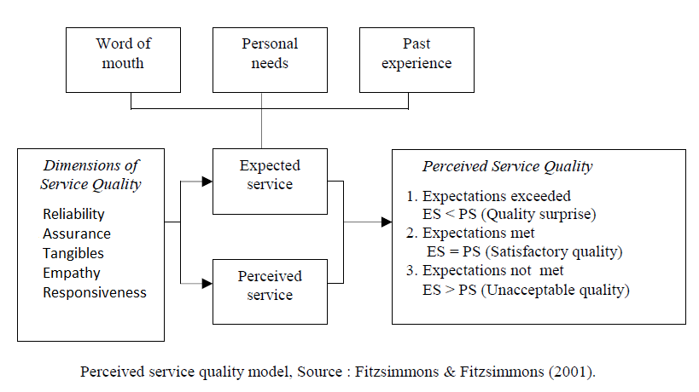
3: Research Methodology and Conceptual Framework
Figure1. Perceived Service Quality Model

Service quality can be measured through five parameters of SURVQUAL as those variables can explain the gap in services offered by different organizations for their end users. These dimensions of service quality are referred as Tangibility, Reliability, Assurance, Responsiveness and Empathy. Services-oriented organizations translate these dimensions into objectives in the terms of Expected service offered to their customers. Expected service from customers’ perspective can be judged on the basis of word of mouth, personal needs and past experience. Service organizations collect data from their customers and analyze their personal needs in order to offer best services within target market. Customers provide valuable knowledge based on their past experiences availing services within service market.
Service providers try their best to implement service strategies which can meet the expectation of customers resulting perceived service exceed than expected service. In ideal conditions, service offered by organization delight the customers as the quality of service exceed than expected service. Organizations try to meet the standard of their services at particular level which can satisfy their target markets. In the case when service standard decline at particular level, the customers consider it as unacceptable service. This situation may lead to difficulties of survival of service-oriented organizations because customers may switch their preference to competitors’ products who offer services which exceeds than their expectations.
  - Research Design
As the research paper explicitly explores the service quality dimensions engaging the SERVQUAL scale, this is a descriptive study that is structured to investigate the factors that may result in customer’s satisfaction and dissatisfaction. Though quality and satisfaction level cannot possibly be quantified, and is based on subjective justifications through detailed explanations but this research is a quantitative research as it has been investigated and relate the factors contributing towards customer’s contentment, where the ‘customer’s expectations’ and ‘customer’s perceptions’ are the independent variables determined through the performance of the dependent variables; ‘reliability’, ‘assurance’, tangibility’, ‘empathy’ and ‘responsiveness’.
  - Sources of Information
The study includes both primary and secondary data collection techniques as both were necessary to include. Survey was conducted to figure out perceived service and possible service expectation by passengers. Similarly, Relevant chunks of information have been collected through the official website of Pakistan International Airlines with the expert opinions of different authors who have previously investigated the quality dimensions of the specific airline which were used in contrast to the customers’ gap scores in order to reach conclusions and put together a few recommendations for the study.
  - Questionnaire Design
The instrument encompassed close-ended questions representing the 5 service quality dimensions through the expansively designed 30 statements. These 5 independent variables of RATER technique, were signified through a comprehensive set of questions segregated into five parts where each fragment represents each variable individually and then assessed in light of the independent variables i.e. customer expectation and customer perception. The questionnaire measurement items were adapted from the airline service quality scale based on a 5-point likert scale interrelated from 1 to denote the service quality as ‘much worse than expected’ towards 5 to denote the service quality as ‘much better than expected’, with respect to customer perception and customer expectation. The personal section of the instrument carried demographical interrogations such as age, gender and educational level, while questions were included to inspect the frequency of airline trips taken in the last 12-months’ time by the respondent through PIA.
  - Population and Sample Size
The population frame of this study is limited to all the passengers who have had an experience to fly to or from Quetta through Pakistan International Airlines as this helped gain better insights of the airline’s service quality measures pertaining to a definite group of customers. To ensure objectivity and accurateness a total number of 120 passengers, who had a flight experience through PIA’s operations in Quetta at least once since the last 12 months were chosen. To determine the sample size rule of thumb laid by Roscoe (1975) came in handy, who refers a sample size of larger than 30 and less than 500 as being the quite adequate size for most researchers. Hence a sample size of 120 passengers has been studied for the most accurate descriptive explorations.
  - Sampling Method
The SERVQUAL framework helps a great deal to study the individualized and customized aspect of the service. In this regard convenience sampling method was devised as it required the questions to be answered by the PIA passengers having their most recent encounter in the last 12 months period, and reaching to this number through any other means was not merely possible.
  - Data Analysis Technique
The data acquired was evaluated through the descriptive statistical tools i.e. frequency charts and means scores. For this purpose Microsoft Excel Suite 2007 was used along with the SPSS Software to reach to the conclusions. In additional to that, statistical tool Factor Analysis is used to determine the factor loading and correlation among the variables, and to determine the service quality scores the difference between mean perceptions and mean expectations was identified, for this purpose ‘One Sample T-test’ was run to find out the average scores of both the variables and find the gap score (P-E).

- Data Analysis and Interpretation of Data
  - Factor Analysis
In this research the statistical tool Factor analysis is used in order to reduce the numbers of variables which helps to identify the variance of factors. Principle Component Analysis method of Factor Analysis is used as it is most common used and default method in SPSS.
    - KMO and Bartlett’s Test
Table1. KMO and Bartlett's Test
Kaiser-Meyer-Olkin Measure of Sampling Adequacy. |  | .857
Bartlett's Test of Sphericity | Approx. Chi-Square | 1831.827
Bartlett's Test of Sphericity | Df | 435
Bartlett's Test of Sphericity | Sig. | .000
This test shows significant level as it is .000 which according to rule must be less than .05. This analysis considered approximately Chi-square 1831.827. The KMO and Bartlett’s Test shows that, all the variables are correlated significantly different than zero; so this analysis is considered as extremely significant.
    - Total Variance Explained
In this research 30 variables are used, as purpose of Factor Analysis is to reduce the variables into small number of components, total 8 factors are generated so for. As the matter of definition, the number of variables we enter in our analysis must be equal to number of components shown in Total Variance Table Explained Table. According to rule of thumb, the variables having Eigenvalue greater than 1.0 are retained and kept, as below of 1.0 Eigenvalue variables are not extracted in Total variance Explained Table. Extraction sum of square loading has loaded 8 components having 1.0 or above Eigenvalue. One way to know how good job this analysis has done by explaining the relationship between the variables as the % of cumulative variance is 67.64 which is considered pretty good in practice. To identify the variance percentage, the Eigenvalue of each factor is divided by number of variables like 10.469/30=0.3489 which indicates 34.896 percentage of variance is explained by the component.
    - Scree Plot
Figure. 2 Scree Plot
. 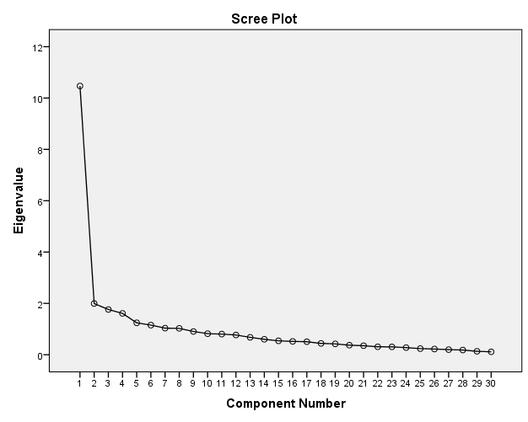
Talking about Scree Plot, it takes data (Eigenvalue) from Total Variance Explained Table and show the value of each component. The Scree plot clearly shows that there is big drop from component 1 to 2 while remaining 29 variables construct a flat line showing slow change.
  - Instrument’s Reliability Check
To scrutinize the in-flight service operations an instrument composed of the 30 service attributes scale was adapted and filled by the PIA passengers residing in Quetta as they shared somewhat similar socio-economic demographics. To check the instrument’s reliability, Chronbach’s Alpha test was run that turned out to be 0.933 for the all 30 attributes. In addition to reliability check, each variables’ reliability is also mentioned here as follow;
Table. 2 Cronbach’s Alpha
S.No | Variable | Cronbach’s Alpha | N of items
1 | Tangibility | .751 | 5
2 | Reliability | .832 | 6
3 | Responsiveness | .838 | 6
4 | Assurance | .818 | 8
5 | Empathy | .783 | 5
6 | Cumulative Reliability | .933 | 30

Out of the 120 passengers in total, 47 female passengers and 73 male passengers participated in the survey that showed a percentage of 39.2% and 60.8% respectively. Besides, the response rate of this study was 100% in which 45% respondents were postgrads, 42.5% undergrads and around 12.5% were in their college years. Moreover, the highest number of respondents was the youth under the age bracket of 21-30 years i.e. 56.7%, likewise, in the age slot of 10-20 years; 11.7%, 31-40 years; 18.3%, 41-50 years; 7.5% and 5.8% respondents participated having age above than 51 years. Furthermore, about 96 respondents had taken a number of 1 to 5 flights in the most recent 12 months that meant around 80% whereas, 18 respondents had taken 6- 11 and about 6 respondents more than 11flights. In comparison to this, the number of flights taken through PIA in the 12 months period was as follows;
Table3. Descriptive statistics of Respondents

Number of respondents | Frequency of flights | Percentage of flights | Cumulative Percentage
113 | 1 to 5 | 94.2 | 94.2
6 | 6 to 10 | 5 | 99.2
1 | 11 to above | 0.8 | 100
Total 120 |  | 100 | -

Table4. Mean Table

Code | Attributes | Mean Perception  (P) | Means Expectation  (E) | Mean Difference Gap  (P-E) | Perceived Service Quality
TAN1 | Appearance, attitude and uniform of employees | 3.23 | 3 | 0.233 | Good
TAN2 | In-flight modern and clean facilities | 2.98 | 3 | -0.017 | Poor
TAN3 | Variety and quality of in-flight foods | 2.38 | 3 | -0.625 | Poor
TAN4 | Variety and choices of in-flight entertainment facilities | 2.14 | 3 | -0.858 | Poor
TAN5 | Providing visually appealing equipment. | 2.48 | 3 | -0.525 | Poor
REL1 | Efficiency of check-in process | 2.88 | 3 | -0.117 | Poor
REL2 | Efficiency of check-out process | 2.92 | 3 | -0.083 | Poor
REL3 | Meeting time commitments during in-flight operations | 2.51 | 3 | -0.492 | Poor
REL4 | Remedial procedure for delaying and or missing baggage | 2.42 | 3 | -0.583 | Poor
REL5 | Providing in-flight services consistently | 2.56 | 3 | -0.35 | Poor
REL6 | Performing the service right the first time | 2.62 | 3 | -0.383 | Poor
RES1 | Capable to response to emergency situation | 2.82 | 3 | -0.183 | Poor
RES2 | Prompt attention to passengers’ specific needs | 2.82 | 3 | -0.183 | Poor
RES3 | Understanding the specific needs of passengers | 2.63 | 3 | -0.375 | Poor
RES4 | Keeping customers informed about when service will be performed | 2.83 | 3 | -0.167 | Poor
RES5 | Prompt response of cabin crew member to your request or compliant | 2.78 | 3 | -0.217 | Poor
RES6 | Capability to respond to the technical flight issues | 2.78 | 3 | -0.217 | Poor
ASS1 | Sincerity and patience in resolving passengers’ problems | 2.67 | 3 | -0.333 | Poor
ASS2 | Probability of flight breakdowns during the mid-flight operations | 2.59 | 3 | -0.408 | Poor
ASS3 | Safety performance of airline. | 3.02 | 3 | 0.017 | Good
ASS4 | Knowledgeable and skillful provision of services | 2.97 | 3 | -0.033 | Poor
ASS5 | Responsive attitude to passengers’ complaint. | 2.78 | 3 | -0.225 | Poor
ASS6 | Employees instill confidence to passengers’ complaints | 2.98 | 3 | -0.225 | Poor
ASS7 | Employees are consistently courteous | 2.97 | 3 | -0.033 | Poor
ASS8 | Knowledgeable employees to answer customers’ questions. | 3.03 | 3 | 0.033 | Good
EMP1 | Spontaneous care and concern for passengers’ specific needs | 2.61 | 3 | -0.392 | Poor
EMP2 | Frequent cabin crew rounds by flight attendants | 2.80 | 3 | -0.2 | Poor
EMP3 | Having sound loyalty program to recognize you as frequent customer | 2.68 | 3 | -0.317 | Poor
EMP4 | Having sound mileage program. | 2.75 | 3 | -0.25 | Poor
EMP5 | Having travel related programs i.e. travel insurance | 2.49 | 3 | -0.508 | Poor
 | Overall Customer Satisfaction | 82.20 | 90 | -7.8 | Poor
Out of the over-all elements, respondents chose ‘tangibility’ as the worst service attribute with a negative SERVQUAL score of -0.3584, though in the same classification ‘appearance, attitude and uniform of employees’ had the highest mean score i.e. 0.233, which actually surpassed customers’ anticipated service quality. Moreover, the worst service feature was thought to be the’ variety and choices of in-flight entertainment facilities’ with a negative SERVQUAL score of -0.858, that was also the part of tangible service attribute.

Table 5. Average Mean Difference Gap
Service Attribute | Average Mean Perception (P) | Average Mean Expectation (E) | Average Mean Difference. Gap (P-E)
Assurance | 2.88 | 3 | -0.12488
Responsiveness | 2.78 | 3 | -0.22367
Empathy | 2.67 | 3 | -0.3334
Reliability | 2.67 | 3 | -0.33467
Tangibility | 2.64 | 3 | -0.3584
The average mean differences of each attribute show that respondents rate ‘assurance’ as a particularly touches the average mean expectation but still need to concentrated to cross at least 3.0 of average means expectation. Assurance contributes with the average score of -0.124 in terms of mean difference gap in quality when comparison to the other four attributes. This suggests that passengers are in some way are contented by the service provision of the frontline staff who they may find courteous during their mid-flight experience. Responsiveness has been rated less satisfactory attribute with the average mean score of -0.223 that again shows a partial satisfaction on the part of employees who are ready to lend their support and provide prompt service however, the service does not exceed customer’s expectations. Empathy and Reliability have been evaluated with the equal perceived averages of 2.67; however, meticulous assessment shows that Empathy has been saved by inches to take the third position in the respective order.
4.4 Service Attribute Assessment
Chart1. Tangibility
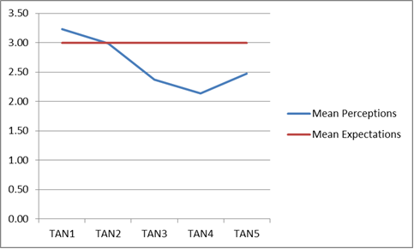
Considering the SERVQUAL scores of each of the five elements of Tangibility, passengers evaluate appearance and attitude of the crew members as very desirable. In addition to that the in-flight clean amenities are also averaged to touch the expected value with the score of 2.98, while other factors of tangibility like the mid-flight cuisine, entertainment facilities and the attractiveness of the provided equipment is considered to be much dissatisfactory.

Chart2. Reliability
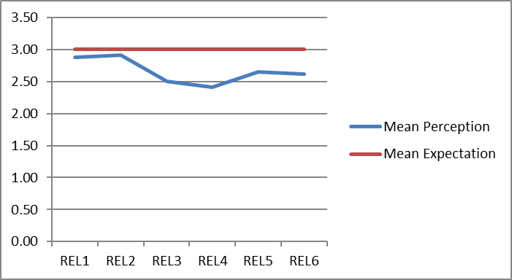
Relative to Tangibility the SERVQUAL scores of Reliability are less dispersed. From meeting the time commitments to the efficiency of the both check-in and check-out process are believed to be dissatisfactory while the remedial procedures regarding any uncertain situation scores the lowest in this attribute with -0.583 gap score
Chart3. Responsiveness
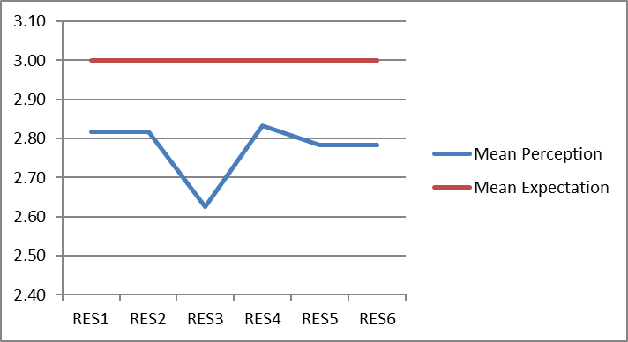
The gap scores of Responsiveness indicate that passengers rate the elements of this attribute more or less with the same averages within the range of 2.27 - 2.85 though, they believe the front-line staff fails to understand the individualized needs of the passengers and rate the perceived score 2.63 i.e. the lowest of the other elements.
Chart4. Assurance
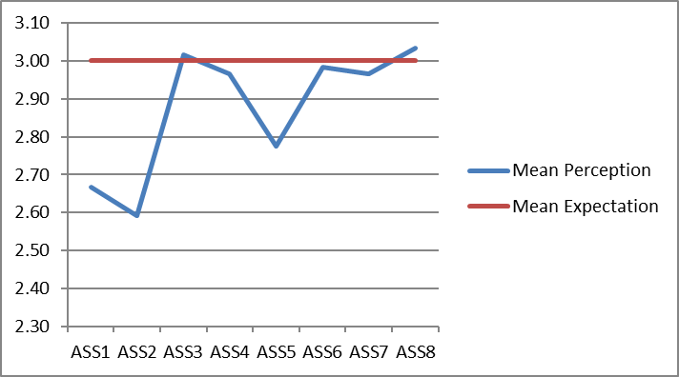
Assurance has been observed as the least substandard attribute when compared to other determinants; here travelers rate the safety performance of the airline as better than expected with a positive gap score of 0.017 but show negative concern regarding the probability of the flight breakdown with the least gap score of -0.408.

Chart5. Empathy
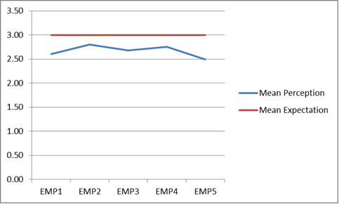
The gap scores of Empathy were much steadily dispersed within the perceived mean score range of 2.40 to 2.80, where customers showed the need of having a proper travel insurance program during their entire chain of travel.
5.0 Conclusions and Recommendations
5.1 Conclusion
Chart6. Average Mean Difference Gap
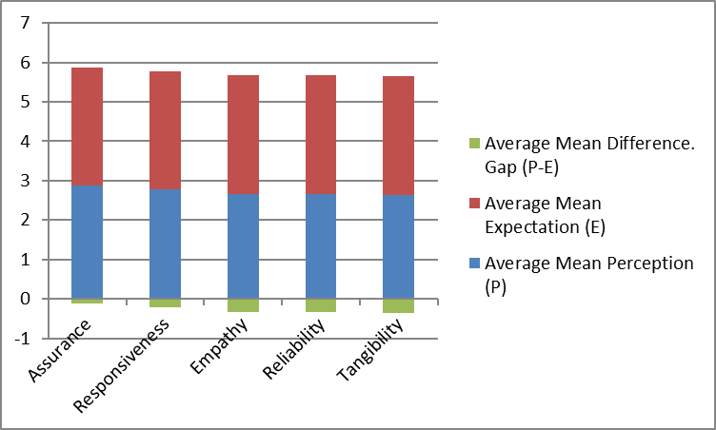
The overall purpose of this research is to see if the mid-flight hospitality provided by the Pakistan International Airlines is entirely aligned with the customers’ expectations of a quality service. Evidence from the study infer that PIA’s perceived midflight hospitality services are deemed to be worse than expected in accordance to the five main service attributes; responsiveness, assurance, tangibility, empathy and reliability with an overall negative gap score of -7.8, however regarding the courteousness and knowledgeable behavior of the frontline crewmembers, their perceived service value exceeded their expectations. Study displays that customers are happy with the appearance, attitude and uniforms of the employees. In addition to that passengers provide positive feedback regarding safety performance of airline, and they are also satisfied with the knowledgeable and skillful provision of service by PIA employees. These were positive signs; however other variables show poor performance of the PIA and leads to passengers’ overall dissatisfaction.

  - Recommendations
Indications from the study suggest that Pakistan International Airlines needs to formulate customer-oriented approaches towards the improvement of its mid-flight operations. The information available on the airline’s official website regarding its service offers are conflicting to the service customers have actually come across which then proves damaging to the airline’s image. Following main steps should be taken by PIA immediately to fill the gap in customers’ expectations and perceived service.
- Provide up-to-date information to customers through official website of PIA as current information is conflicting to the service which may result to harm the image of airline.
- Make efficient process of check-in, checkout, quality in-flight meal, diverse entertainment to the passengers.
- Improve safely measures, train front line crew members in order to motivate passengers preferring PIA airline.
- Improve the quality of tangible elements like seating capacity, inflight quality visual equipment etc.
- Showing sincerity and patience in resolving passengers’ problems.
- Handling promptly customers’ complaints and Provide positive and constructive feedback through sincere and responsive attitude.
The above-mentioned recommendations should be taken at priority basis by PIA as service expectation are diminishing and leaving negative perception in the minds of passengers. The customers rate the variable as worst is entertainment which must be given proper concentration trough effective and healthy service strategies. PIA was amongst the best airline companies in 70s and 80s, these service upgradation strategies will make PIA again sound in financial matters and can win customers hearts and can make PIA first choice to travel.

References
- Baloch, Q. B., Jamshed, J., Zaman, G. 2014, “Enhancing Service Quality & Reviving Competitiveness of Pakistan International Airline” Abasyn Journal of Social Sciences, Vol. 7 (2), Issue 2, pp 346-359.
- Chikwendu, D.U Ejem, E., Ezenwa, A. 2012, “Evaluation of service quality of Nigerian airline using servqual model. Journal of Hospitality Management and tourism”, Vol. 3, issue 6, pp 117-125.
- Christian Gronroos. 2001, The perceived service quality concept- a mistake? Managing service quality. An international Journal, vol 11, iss 3, pp150-152
- Elliott, K.M., Roach D.W. 1993, “Service Quality In The Airline Industry: Are Carriers Getting An Unbiased Evaluation From Consumers?” Journal of Professional Services Marketing, Vol. 9, issue 1, pp 71-82.
- Gilbert, D., Wong, R. K.C. 2003, “Passenger expectations and airline services: a Hong Kong based study. Tourism Management”, Vol. 24, issue 5, pp 519-532.
- Gourdin, K.N. 1988, “Bringing Quality Back to Commercial Air Travel”, Transportation Journal, Vol. 27, issue 3, pp 23-29.
- Huang, Y.K. 2009, “The Effect of Airline Service Quality on Passengers’ Behavioural Intentions Using SERVQUAL Scores” A TAIWAN Case Study. Journal of the Eastern Asia Society for Transportation Studies, Vol. 8.
- Imrie, B.C., Cadogan J.W., McNaughton R. 2002, “The service quality construct on a global stage. Managing Service Quality”, An International Journal, Vol. 12 Issue 1, pp
- Oldfield, B.M., Baron S. 2000, “Student perceptions of service quality in a UK university business and management faculty”, Journal of Quality Assurance in Education, Vol. 8, Issue 2, pp 85 - 95.
- Parasuraman, A. Zeithaml, A., & Berry, L. L. 1988, “A Conceptual Model of Service Quality and Its Implications for Future Research”, Journal of Marketing, Vol. 49, issue 31, pp 41-50.
- Shanka, M. S. 2011, “Measuring Service Quality in Ethiopian Airlines”, Journal of Educational and Social Research, Vol. 2, issue 9, pp 173-188.
- Zainol, Asif Zamri and abd Rahim Romle. 2007, “The truths of service quality (passenger handling) in airlines industry: a descriptive exploration between Malaysia Airlines and AirAsia.” Journal of Global Business Management 3 (1) page 1-7.

Acknowledgement
I would like to express my gratitude to my friend Dr. Aftab A. Shaikh for his continuous support and guidance. He remained very cooperative and sincere at every stage of my academic as well as social life. In addition to that, I am thankful to my family and friends who provided their support and guidance in order to accomplish this research task.
I would not forget the sincere help of my students who helped me in collection of data from PIA, Pakistan. Without my students this project was almost impossible to accomplish.

