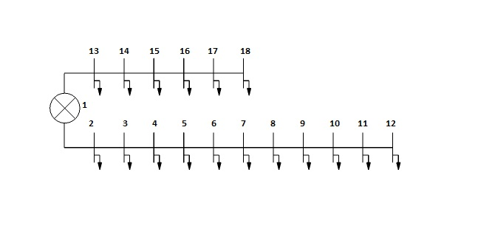
Fig 1: A 400V distribution system with two feeders

Fig.2: Main feeder- 1 with a PV system at Node 12 to feed a 3 hp load.
Fig.3: Main feeder – 1 with a PV system at
Node 11 to feed a 5 hp load.

Fig.4 Main feeder- 2 with a PV system at
Node 16 to feed a 15 hp load.

