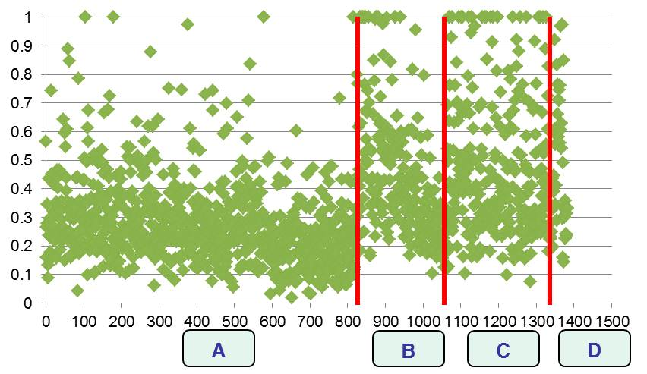 | No. of DMUs 1,382  Average efficiency 0.3532  SD 0.2051  Maximum efficiency 1  Minimum efficiency 0.01823  Total number of simplex iterations 21,332  No. of efficient DMUs which efficiency is 1 37 (2.7%)
Fig. 1. Efficiency distribution of BT projects

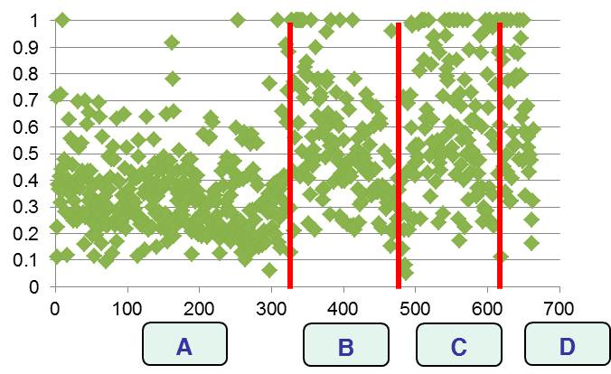 | No. of DMUs 664  Average efficiency 0.4677  SD 0.2381  Maximum efficiency 1  Minimum efficiency 0.0491  Total number of simplex iterations 16,418  No. of efficient DMUs which efficiency is 1 44 (6.6%)
Fig. 2. Efficiency distribution of NT projects

